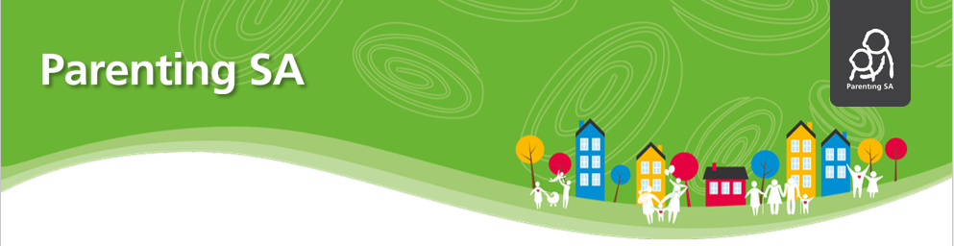

**Parenting and Family Support Program’s**

**Building Coping Skills**

**in children and young people**

**Building Coping Skills** is a FREE 2 part workshop that helps you as parents and carers to support your child or young person’s resilience.

Our workshops are full of helpful information with a choice of simple, practical strategies that each family can adapt for their own parenting situations.

**Topics to support your parenting include:**

* + - * **What is resilience?**
      * **Understanding stress for children and young people**
      * **The benefits of ‘considered risks’**
      * **How parents can help to build resilience**

Our workshops are based on the latest parenting research and use information from **Parenting SA.**

*Light refreshments and crèche provided. (Bookings essential)*

**Where:** Cowandilla Children’s Centre, 34 Wilson St, Cowandilla

**When:** Thursday 18th & 25th November 2021

**Time:** 12:30pm – 2:30pm

**To book:** Contact the Children’s Centre on 8352 5346

Everyone is welcome, however bookings are essential, Spaces are limited

* Please arrive 10 minutes early to register *

Delivered by the Department of Human Services

Parenting and Family Support Team

**To book into this 2 part workshop phone Cowandilla Children’s Centre on 8352 5346**