Curriculum

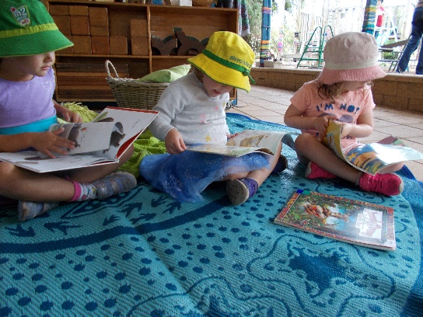
Our curriculum is based on the National Early Years Learning Framework - Belonging, Being and Becoming (EYLF). It describes the outcomes on which learners from birth to five years of age can expect their education to be built.

LEARNING OUTCOMES:
- Children have a strong sense of identity
- Children are connected with and contribute to their world
- Children have a strong sense of wellbeing
- Children are confident and involved learners
- Children are effective communicators.

The Framework supports a model of curriculum decision-making as an ongoing cycle. This involves educators drawing on their professional knowledge, including their in-depth knowledge of each child.
Working in partnership with families, educators use the Learning Outcomes to guide their planning for children’s learning. In order to engage children actively in learning, educators identify children’s strengths and interests, choose appropriate teaching strategies and design the learning environment. Educators carefully assess learning to inform further planning.

Under the Children’s Protection Act Department for Education staff have a duty of care to protect and care for every learner and to ensure that effective abuse prevention programs are implemented. Across your child’s year at kindy we will be working with them to explore the Child Protection Curriculum - covering rights, responsibilities, relationships and ethical behaviour.

Play

Through play children express their ideas and engage in exploration, imagination, experimentation and manipulation.

These skills are essential for the construction of meaning and knowledge that will contribute to the development of representational thought.

It is through their exploratory, sensory, social, physical, constructive, imaginative, projective, role and dramatic play that children examine and refine learning in relation to environments and other people.

As children's play becomes more rule oriented, their social, emotional and intellectual development is enhanced through the development of autonomy and cooperation
.
Children's knowledge, skills, understandings and dispositions will be extended and strengthened effectively through both child-initiated and adult-initiated play experiences.

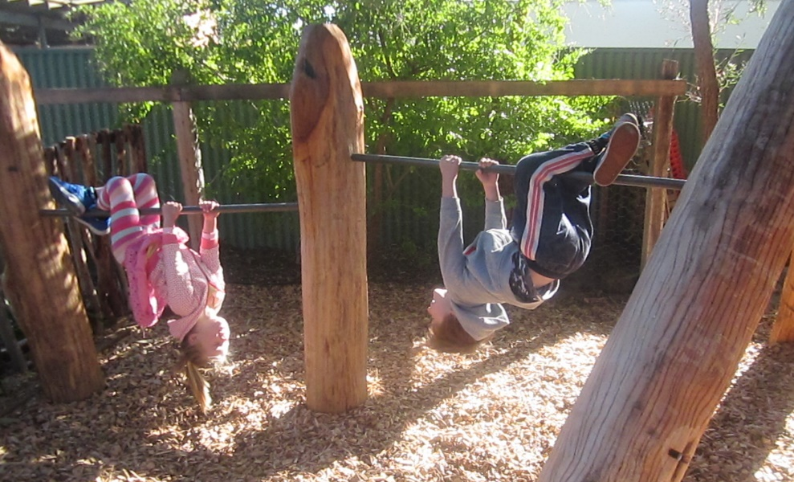

Information about your child's learning and development is available through:

- Statement of Learning:
At the end of your child’s time at kindy a copy of their statement of learning will be given to you and a copy will be forwarded to their school. This is an accumulative reflection of your child’s learning during their time at kindergarten.
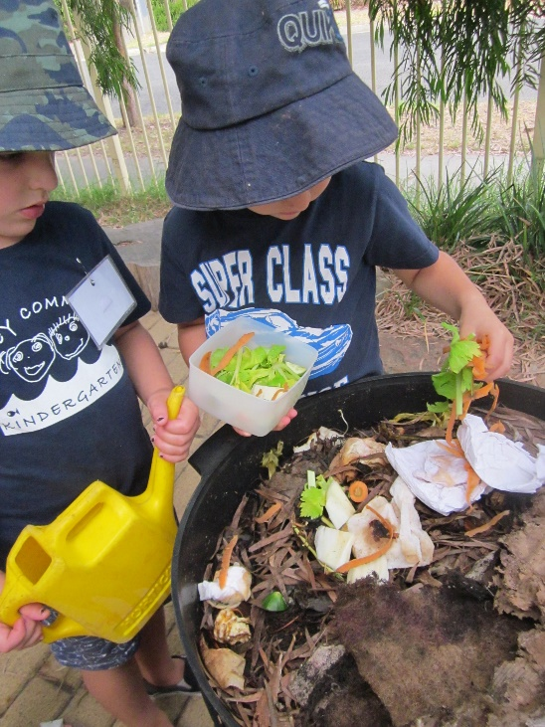
The Statement of Learning is informed by the EYLF.

- Newsletters: We find email to be very effective for keeping parents informed about what is happening at kindy. If you have an email address could you please make sure that it is written on your child’s enrolment form. Newsletters are also displayed on the notice board and some hard copies are located next to the sign on sheet.

- Portfolios: Each child’s learning will be shared with families via the Seesaw app.

- Work displayed or on show at the kindergarten

- Discussion or chats with staff team can be held at any time during your child's time at Kindergarten. Appointments are appreciated to avoid interruptions through sessions.

- Program information is written up every two weeks and is on display. Parent contributions to this program are very welcome.

