**Attendance**

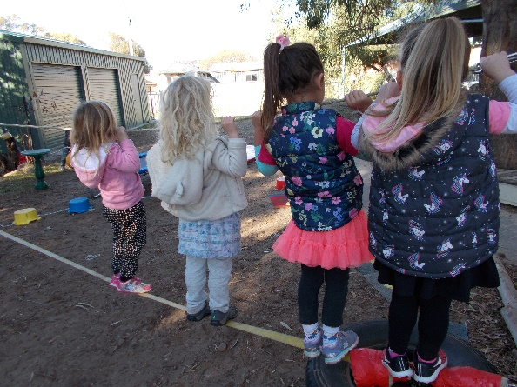

Children who attend kindergarten regularly have opportunities to develop friendships, learn new things, build on what they already know and follow routines. Regular attendance supports your child’s participation in the education program so they feel part of the group and teachers can plan to support their learning.

Our funding is also tied to attendances. We are allocated staffing and funding based on who attends.

Regular attendance benefits us all.

**What to bring:**

Each child will be given a named tag which we will attach to their kindy bag. This will have words and pictures to help them get organised for kindy each day. They need to bring:

1. A **bag** that your child can manage without help and that they can easily recognise. We recommend that the name be written on the outside.

2. A **hat** which must be either wide brimmed or with a flap at the back. Caps are not suitable. This must be worn for outside play from1st September until 30th April.

3. **Spare clothes** in case of accidents or messy play

4. **A lunch box** with a healthy sandwich, wrap, salad etc, ensuring your child can open their own items. Please try to avoid packaging as we encourage ‘nude food’.

5. **In their Kindy bag** include 2 pieces of fruit, one for the morning and one for the afternoon (separate from their lunch box please)

6.A **water bottle**.

**Please label all items with your child’s name.**

**Healthy Lunch Box Ideas**

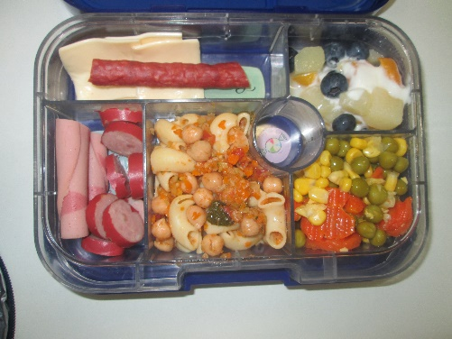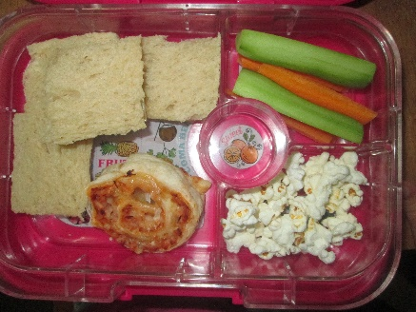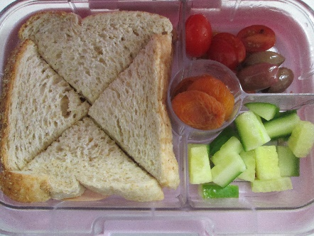

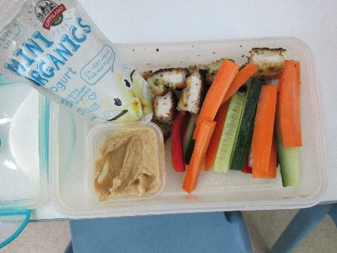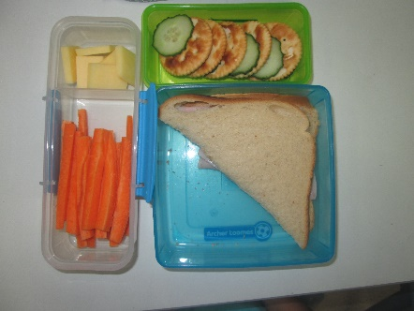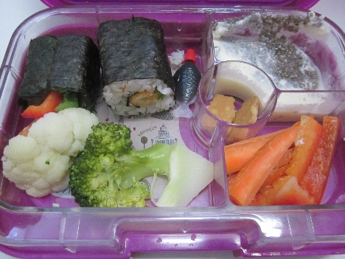

**What to leave home**

Toys or special items unless they are related to the curriculum. Should your child need a security toy please discuss with an Educator.

**Clothing:**

Children need to wear clothes that are comfortable and that they can manage themselves. The children are very active at kindy and need to wear clothing and footwear that will not hinder their running, jumping, climbing etc. We do provide children with smocks for messy activities but children will still get wet and dirty sometimes. Clothes that are well worn are great for kindy.

Weather appropriate clothing will allow children to feel comfortable during nature play.

Please label all your child’s clothing with their name, including their hat to prevent lost items.

**Birthdays:**

We celebrate children’s birthdays by lighting candles on a pretend cake and singing Happy Birthday.

In line with our Healthy Food and Nutrition Policy we do not celebrate with cakes or other food treats.

**On arrival:**

On arrival and when leaving, please initial your child’s name on the sign in sheet.

This is important in case of emergencies.

The sign in sheet is located on the bench near the door.

Please write in the diary if someone different will be collecting your child.

The notice pockets are located on the main door and it is a good idea to check yours every day for any information. We use them to communicate small accidents/incidents that may have required a bandaid or cold pack or change of clothes.

**How you can help:**

We welcome and enjoy parents being part of our learning environment.

If you have skills/knowledge you can share with us we would love to know, eg cooking, playing an instrument, a sport, hobby, special interest or work interest eg life saving, police.

We always need materials for pasting and woodwork, so boxes, material, lids, corks, feathers, gumnuts, cards, wrapping paper, shells, ribbons, leather and so on are welcome. The exceptions with boxes are washing powder, cigarette and match boxes, toilet rolls and medical boxes.

Parent Rosters are placed near the entry where you can add your name if willing to help.

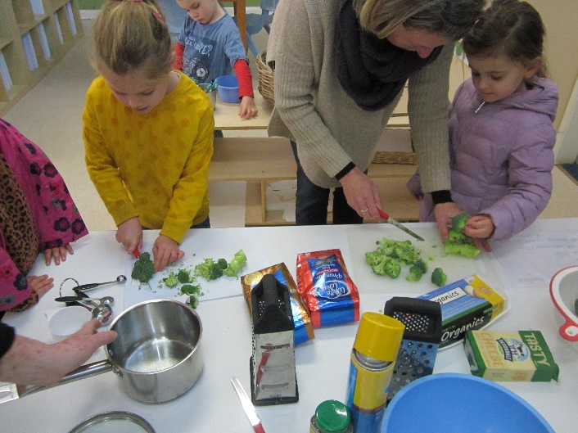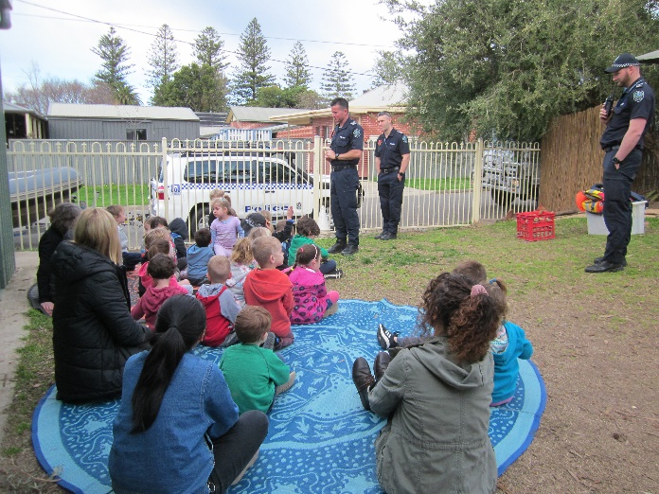Weekly volunteers are needed to help with washing, and weekend caring for our resident chickens.

**Child and Family Health Checks**

During their year at kindergarten, families will be invited to book a health check for their child.

These checks often pick up things that have been previously missed and are a great way to reassure you that your child’s development is on track.

If you would prefer not to wait for an invitation you can contact the Cowandilla Child and Family Health Service on 1300733606 to make your own arrangements.

**Health and Safety Procedure**

If your child is unwell prior to coming to kindergarten it is in the best interests of the other children to keep them home until they are well. Please inform the centre when your child has an infectious disease so the spreading of disease can be minimised. A number of contagious illnesses require children to be exempt from attending kindergarten – please talk to staff if you are unsure.

Minor injuries will be treated by educators, recorded and reported to parents.

In the event of your child becoming ill or having an accident at kindergarten, we will contact you or your emergency contact person. In an emergency educators will call an ambulance, which is at the families’ expense.

***Please always let us know of any changes to contact telephone numbers and your home address.***

Staff must be notified of any allergies your child has. A health support plan must be completed and signed by the doctor before staff can administer any medication. Any asthma and severe allergy medications are to be given to staff on arrival.

**Complete policies and procedures are available on our website**

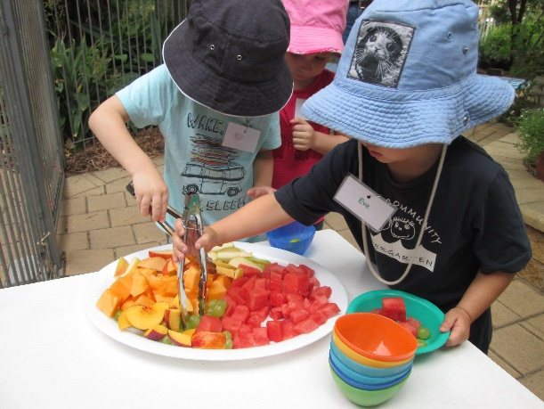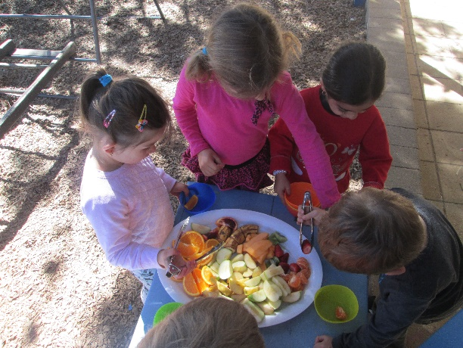

**Healthy Food Supply and Nutrition Policy**

We try to do as much cooking at kindy as we can. Please keep us informed if there are any foods your child cannot eat due to health/ lifestyle or religious reasons.

It is vital that children develop habits of healthy eating from an early age. We also recognize that there are an increasing number of children with health issues and life threatening allergies who have a restricted diet.

In keeping with this, the parents and staff developed this policy.

* We encourage only fresh fruit and vegetables for snack time. Rollups, muesli bars or other sugary or salty snacks are not encouraged.
* Due to possible allergies, we are a **nut free** centre.
* We provide filtered water for drinking and actively encourage children to have regular drinks especially in hot weather. Children only need to bring water to kindy.
* We believe that the preparation, cooking and sharing of food is an activity that is a valuable part of the curriculum. We will use these activities to emphasize healthy eating.
* We celebrate birthdays with a plaster cake and singing. Please do not send treats to share.
* We emphasise and reinforce safety. Children sit while eating and stand still while drinking.

**Skin Protection Policy**

We aim to promote and practice positive attitudes towards skin protection.

* We avoid direct contact with the sun between 11 a.m. and 3 p.m.
* We use the shade of trees and pergolas whenever outside.
* **Children, staff and parents will be expected to wear a broad brimmed or legionnaire style hat for terms 1, 3 and 4** whenever they are involved in outdoor activities.
* Parents are responsible for applying sunscreen to children at the start of each day and staff are responsible for an application at lunch time.

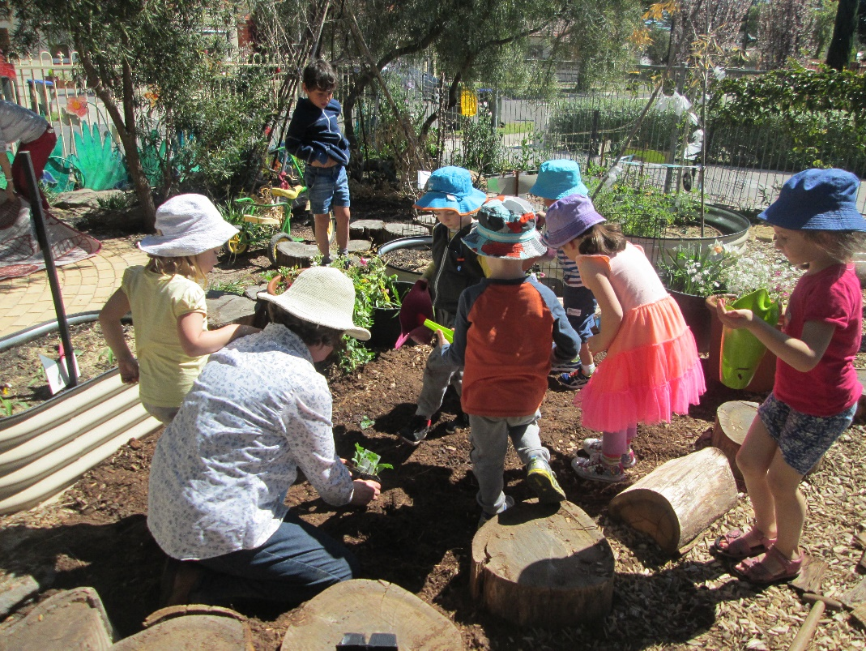

**Behaviour Support Policy**

At Henley Community Kindergarten we aim to support the children to develop positive relationships with other children and adults. We expect our children to behave in a manner which ensures the right of themselves and others to feel safe and valued in the learning environment. Our complete Behaviour Support Policy can be accessed in our policy folder or on our website.

**Concerns and Complaints Procedure**

The relationship between educators and families is fundamental to the quality of care and education that children receive. Open communication in a respectful way ensures the best outcome for you, your child and the Pre School.

The Department for Education and Child Development indicates that a child’s Pre School should be the first point of contact for parents, followed by the Regional Office, and then the Parent Complaint Unit if the complaint cannot be resolved at the local level.

Please know that any issues raised with us will be reviewed to improve our processes and procedures to ensure we develop a strong partnership with families and caregivers.

**The Governing Council welcomes you to Henley Community Kindergarten**

As a parent, guardian or person responsible for a child attending the Kindergarten, it is important that you are aware of the objectives of the Kindergarten.

These objectives are:

*To provide preschool education and other programs and activities to further the development, care and welfare of young children in the community*.

In provision of these services the Centre shall:

1. Emphasize that the paramount consideration is the interests of the children.
2. Reflect the multicultural and multilingual nature of the community.
3. Involve parents and other community members.
4. Evaluate and monitor the nature of these services to ensure that the highest standards are attained.
5. Ensure as far as possible, that special needs of individual groups of children are addressed by the provision of services from the Centre.
6. Ensure that provisions of equal opportunity as detailed in Section 7(c) of the Act are applied to services provided by the Centre.
7. To do all other such things as may be incidental to the attainment of the objects of the Centre.

Support of the above entitles you to be a member of the Kindergarten eligible to vote at meetings.

Members are invited to join the Governing Council which meets approximately 8 times during the year to organize such things as fundraising activities and fund allocation. Governing Council members and

office bearers are elected at the Annual General Meeting., However, members may elect to join at any time during the year. All members are welcome to attend Governing Council meetings as observers. Dates and times of upcoming meetings are published in our newsletters.

We encourage all members to attend the Annual General Meeting, which is usually held in November.

From time to time sub-committees are formed to organize special events, such as the Spring Fair.

**Member participation is vital to the continued operation of the Kindergarten.**

**If you can spare some time and are interested in being part of the Governing Council, please speak to the Director. Your help will be greatly appreciated.**

Last updated May 2021