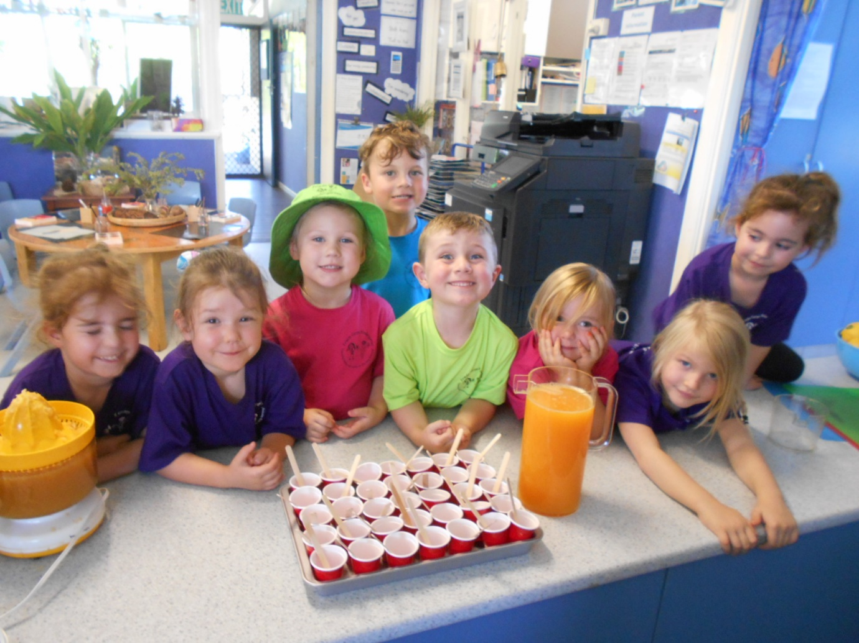

At: Frieda Corpe Kindergarten

Friday 13th March 5.30pm to 6.30pm at kindy.

Families are invited to bring a snack or picnic and have a play at kindy to meet and get to know other families.

Parent Voice (Governing Council) 6.30pm to 8.00pm Tuesday 24th March

**Don’t forget…FULL DAY Friday session: Incursion with Sue Harris Puppeteer at kindy Friday 27th March 8.25am to 3.30pm.**

Monday 30th March CAFHS at kindy

Next terms kindy fees due Friday 3rd April $200

AROUND THE COUNTRY  
Clean Up Australia Day ----------------------- ------------- 3  
Japanese Girls Day ------------------------------------------ 3  
National Ride ‘2’ School Day ----------------------------- 13

Harmony Week ----------------------------------------- 16-22

St Patricks Day ---------------------------------------------- 17

International Day of Happiness ------------------------- 20

World Poetry Day ------------------------------------------ 21

International Day of Forests ----------------------------- 21

World Water Day ------------------------------------------ 22

Earth Hour -------------------------------------------------- 28

Schools Clean Up Day ------------------------------------ 28

Neighbour Day --------------------------------------------- 29

Healthy eating at kindy. Look at our pure orange popsicles. Yum

Worms like to eat at night when it is dark and cool.

The worm tunnels help the water and air to get underground.

Worms are covered in little bristles and have muscles to help them move, they breathe through their skin and don’t have any eyes, they feel vibrations.

We have a poster at kindy depicting what foods/scraps that we can put into our worm farm. The children help to recycle by putting their fruit scraps into the green bin that goes into our worm farm. The children help to look after the worms and gather the worm juice to sell in our harvest cart.

**Worms**

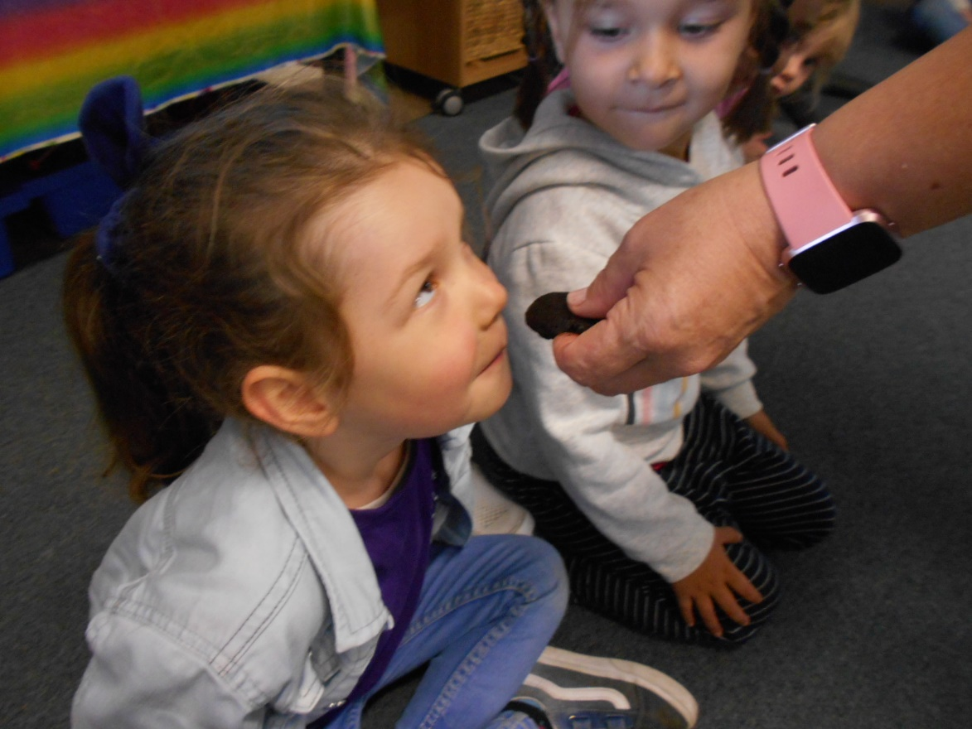

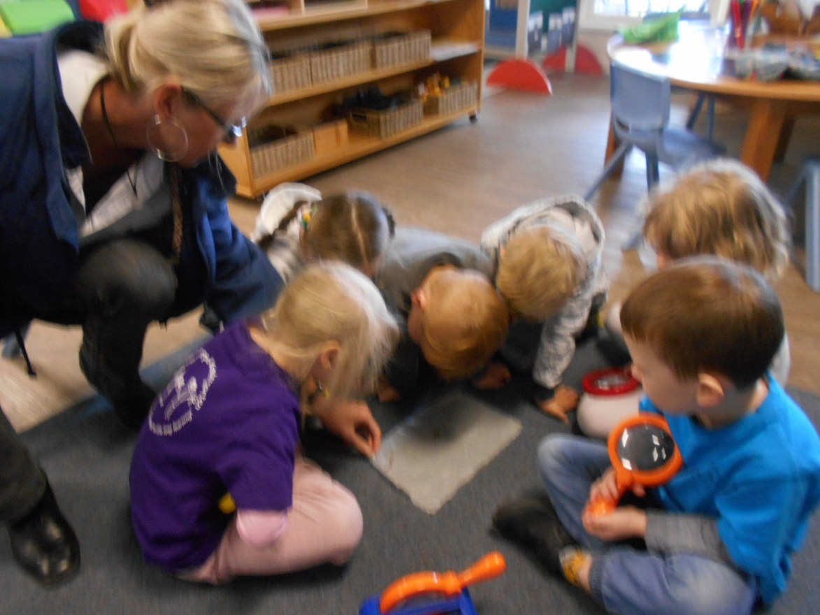

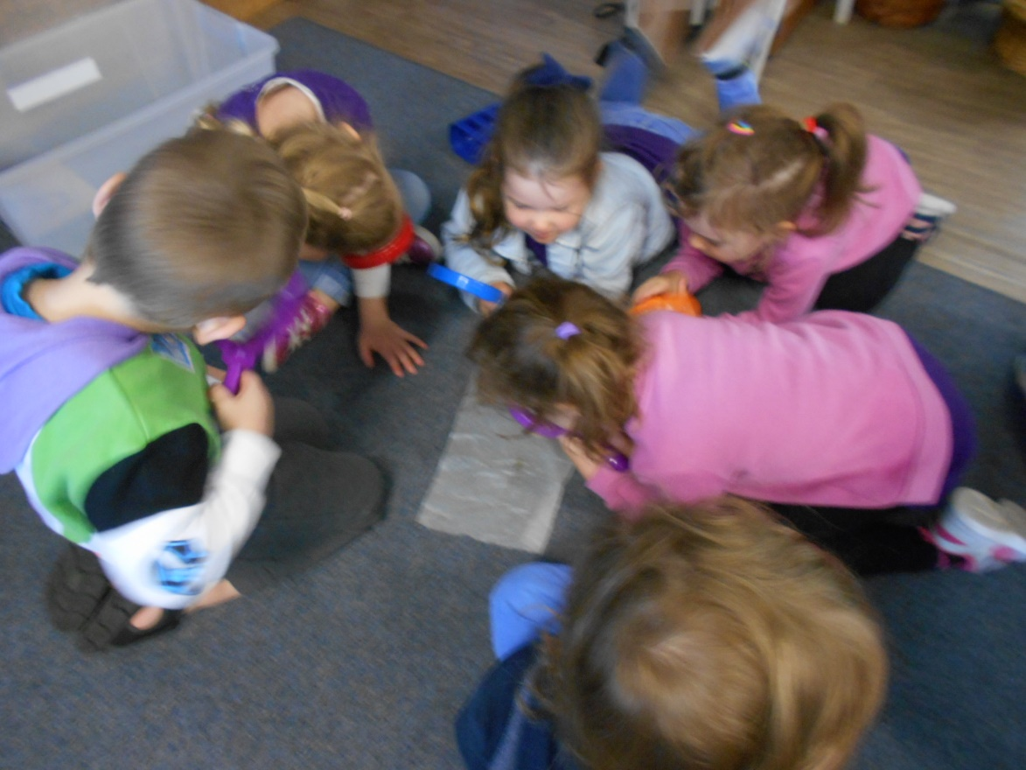

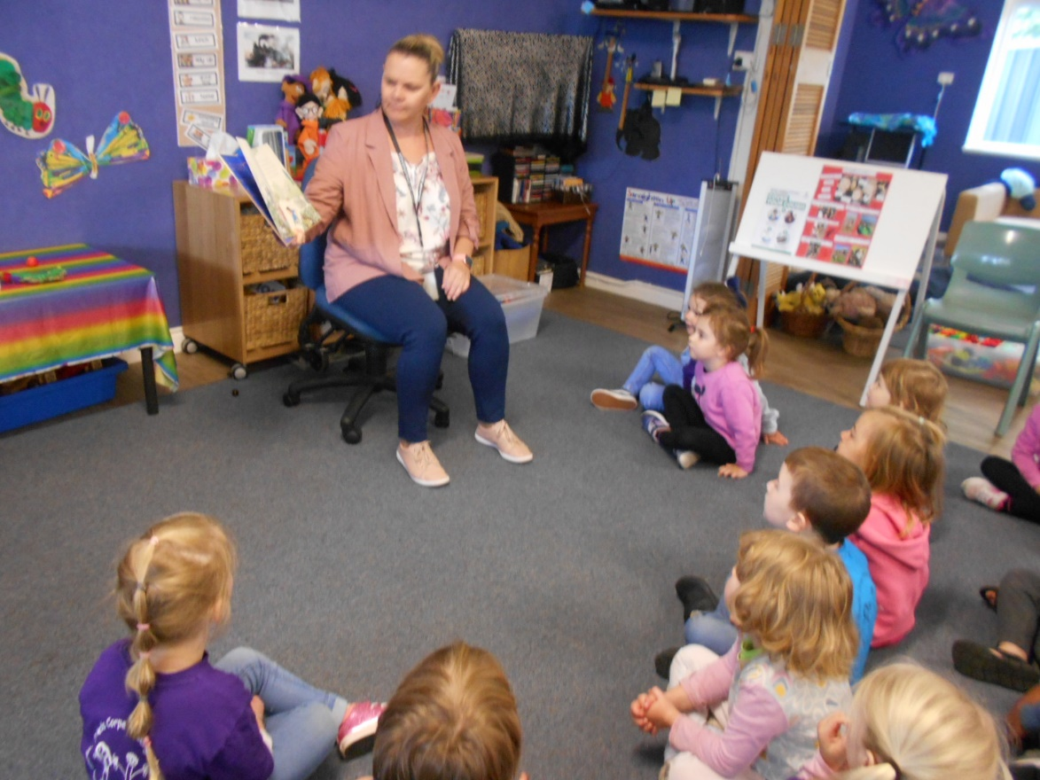

***Malinda from our local council came for a visit to chat with us about composting worms and how they help with recycling and sustainable practices.***

WHAT YOU DO EVERYDAY MATTERS MORE THAN WHAT YOU DO   
ONCE IN A WHILE – GRETCHEN RUBIN

**Frieda Corpe Kindergarten**



Join more than 350,000 students across the nation who will ride, walk, scoot and skate to school on Friday **Find out more at www.bicyclenetwork.com.au**

INTERNATIONAL DAY OF HAPPINESS – MARCH 20  
*“…International Day of Happiness is more than just a fun celebration; it also reminds us all that the world is a better place when we connect with and care about the people around us”*— Dr Mark Williamson. This year's theme is ***Happier Together****,* focusing on what we have in common, rather than what divides us.**Find out more at worldwetlandsday.org** ***www.dayofhappiness.net***



*Apps to help you navigate the noise, be accountable for your actions and achieve your goals.*

**METHOD:**

1. Preheat oven to 180 degrees Celsius (350 F).  Place prosciutto on an oven tray lined with baking paper and bake for 5 minutes or until the prosciutto is golden and crisp.  Roughly chop and set aside.
2. Meanwhile, bring a large pot of salted water to the boil.  Add pasta and cook for a couple of minutes.  Add peas and cook until the pasta is al-dente and peas are tender.  Drain and set aside.
3. In a small jug place the cream, eggs, egg yolks and parmesan and whisk to combine.
4. To assemble: place the pasta, peas, prosciutto, basil and creamy sauce in a large bowl and mix to combine.  Serve with a little extra grated parmesan and a few extra torn basil leaves.

*Recipe and Image from mylovelylittlelunchbox.com*

**INGREDIENTS**6 slices prosciutto

500 grams short pasta

1 cup peas

250 ml cream

2 eggs plus 2 egg yolks

3/4 cup parmesan, grated

1 cup basil leaves, torn

PREP 15 min | COOK 15 MINS | SERVES 6

**CREAMY CARBONARA WITH   
PEAS & BASIL**

NATIONAL RIDE ‘2’ SCHOOL DAY – MARCH 13

National Ride2School Day is held around Australia in March every year. It provides an opportunity for students, parents and teachers to try riding, walking, skating or scooting to school as well as celebrating the regular walkers and riders.

**30 MINUTES – GOAL PLANNER**

**VLADIMIR LYSEEV**

***What if you spent 30 minutes a day on your big goal, or dream? What could you achieve in a week, a month, or a year if you consistently completed small tasks?*** *Set the amount of days for each goal, decide on the time and view detailed statistics on each goal as you work on them.*

**stickK: GOALS & ACCOUNTABILITY   
STICKK.COM, LLC  
*No matter what your goal is - meditate, learn a language, lose weight, quit smoking or drinking, watch less TV, exercise more often… stickK can motivate and help you achieve iT!*** *Created by a Behavioural Economist and a Law Professor from Yale University, stickK is a goal-setting platform, habit tracker and online community of goal-setters.*

**STRIDES: HABIT TRACKER**

**GOALS LLC**

***Track all your Goals & Habits in one flexible free app. With Strides you can track anything - good or bad habits and SMART goals - with reminders to hold you accountable and charts to keep you motivated.***

*Recommended in The New York Times, Strides has been called "the most comprehensive, user-friendly, beautifully designed goal tracking app available." Imagine having all of your most important habits, routines and goals together in one simple to do list. Now you can. :)*

*4. "Your words help me understand you better."*

**Why it works:** Pope's daughter knows she has the power to make herself heard and understood through her words. Imagine teaching that powerful, empowering lesson to your kiddo!

*5. "It seems like you're having a hard time finding the words to explain what you're feeling. Is there another way that you can show me what's going on?"*

**Why it works:**Kids don't always have to "use their words" to be understood, and listening isn't the only tool parents have to understand their children's needs. "Creative expression has been an incredible tool for us," says Sterling.

*6. "I'm your mother, but I don't live in your body. What does it feel like? What's your brain feeling?"*

**Why it works:**This phrase can help teach your children about the mind and body connection and can also help you as a parent to separate the behaviour from the child—they're not *being bad*, they're trying to communicate about what *feels bad.*

*7. "What colour are you right now?"*

**Why it works:** "Children begin to make the mind-body connection, as well as learn appropriate coping skills," Rollo says.

*8. "Let's take a deep breath. Look in the mirror, wipe your face and straighten your clothes."*

**Why it works:**This phrase is like a reset button for kids, teaching them how to centre themselves and move past the meltdown.

Deep breathing is a coping mechanism that works across all age groups—taking a deep breath in and a long exhale helps with getting grounded. A sweet way to teach your child how to do this is by saying, "Smell the flowers, blow out the candles."

*9. "I'm going to go fishing...tell me if I caught anything!"***Why it works:**"Eventually parents 'catch' the right feeling their child has," Chansky says, "or sometimes, just having the conversation helps kids figure out what they need. At the very least they appreciate your efforts at valuing their feelings and trying to help them express them."

None of these phrases and strategies are one-time fixes, but they can all be part of an ongoing conversation between you and your kids. Give your kids the space to provide answers and solutions themselves, and they'll grow to understand how to express their feelings and emotions—even the tough ones.

Akitunde, Anthonia (2020, February 15). 9 phrases that help little kids express big emotions *Retrieved from* www.mother.ly/child/phrases-that-prevent-tantrums

* **When your kid is in full Ron Burgundy-style "I'm in a glass case of emotion" mode, it's easy to match their level of anxiety—thanks to the crying, the screaming, the jumble of words made unintelligible *because* of the crying and screaming...**
* **"For a lot of parents, when they see the meltdown, it's easy for them to notice the behaviour: the falling out, the crying, the emotion," says Brandy Wells, licensed independent social worker specializing in childhood mental health and the creator of My Motherhood Magic. "But usually underneath all of that is a need that needs to be met." Being in tune with your child's needs requires a lot of patience and communication. Yet in an attempt to calm your child as quickly as possible, you might focus on the behaviour, and not whatever's causing it.**  
  "Parents ask their children: What's wrong with you?" says Jacob Kountz, a family therapist in Bakersfield, California. "A more helpful question would be: 'Help me understand what happened.' This type of curious language primes children that they aren't being accused of something, it stays away from unhelpful language such as *wrong*, and it allows children to share their thoughts and feelings."

Raising thoughtful and emotionally intelligent children starts with teaching them how to share their thoughts and feelings.  
  
**The following phrases can help you teach your kids how to express themselves—and help prevent meltdowns.***1. "I can see that you are upset. You are allowed to feel that way. I'm here when you're ready to talk."*  
 **Why it works:** Letting your child know that you see them—that it's okay to have feelings and that you're there for them—helps them feel safe. And having that safety gets them out of melting down and into communicating.

*2. "I would feel [insert emotion] if that happened to me, too."*

**Why it works:** "When kids know that someone isn't going to tell them to feel differently or that their feelings are wrong, they'll eek out that kind of comfort more often," Kudla explains.

*3. "I see that you had a hard time with [x], what can we do to make it easier next time?"*

**Why it works:**Encouraging kids to come up with their own strategies for dealing with frustration is part of a strategy that social worker and mom of three Brandy Wells calls FLIP IT: Identify the feeling (that's the F), then if needed, set an appropriate limit for how to express the feeling (for example, "it's okay to cry, but we don't hit"). I - stands for inquiry, encouraging kids to come up with solutions and strategies of their own. "And then P is prompting—helping them problem-solve," Wells explains. "You want them to practice asking, 'What do *I*need to do?' And if they're not able to do that, then you are able to give them that assistance."

FOCUS: 9 phrases that help little kids express big emotions

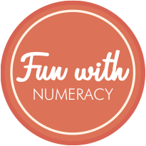

**Supplies: pen and paper.** *The next time you go out, ask your child to spot as many numbers as they can. Write the numbers down as they see them or ask them to try writing them. Even if they aren’t yet able to write clear numerals, the act of scribing a mark for each number is an important stage in early writing. When you get home, have a look at all of the numbers you have collected. Ask your child to find a group of objects to represent the different numbers.*

https://www.3plearning.com/blog/early-numeracy-activities-for-younger-learners/

**Number Walk**

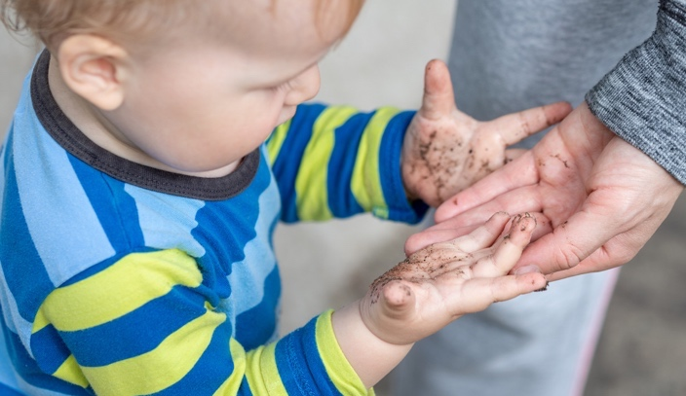

**The concept of germs, for kids, is very abstract. Explaining hygienic concepts to children in an easy-to-understand way can be key to keeping them healthy.**How do you explain the concept of germs for kids to understand? Should you just focus on the actions behind hygiene -- washing your hands, catching your sneeze with your elbow, and not sharing utensils or food -- without dwelling on the explanations? According to health experts, giving kids explanations behind these basic hygiene practices can go a long way towards helping them become more germ-conscious.  
 **Know the Nuts and Bolts of Germ Education**Even young children can understand the basic concept of germs, according to Dr. Dina Kulik, a paediatric emergency medicine specialist and assistant professor at the University of Toronto's Department of Paediatrics. She describes germs as tiny "bugs" that live on all things and explains to kids that sometimes these bugs can make you sick. When you're sick, you miss out on having fun, going to school and going to friends' homes. You can explain to older kids that these germs are called bacteria, she advises, and they're so small they can only be seen with a microscope. While they're not actually insects, they are living organisms that can grow and multiply quickly.  
  
Dr. Danelle Fisher, vice chair of paediatrics at Providence Saint John's Health Centre, agrees on the importance of teaching even very young children about germs. In her opinion, it's important to explain to kids, as they get older, that some germs are good -- for example, probiotics -- and that others are bad, such as cold viruses. When they get even older, you can explain the difference between viruses and bacteria to them, so they understand why antibiotics can help with some illnesses, but not others.  
  
Point out several examples of ways that your child can avoid becoming sick from germs, such as coughing into her sleeve or washing her hands after blowing her nose. And there's one important step of teaching about germs for kids that many parents miss: having your child repeat back to you what you said, so that you know that she understands it. Dr. Fisher believes that this step can help you clear up any misunderstandings before they take root.  
  
Having a hard time figuring out how to explain such an abstract concept to your child? Consider using outside sources. "As paediatricians, we're always happy to help parents explain complex ideas to their children," says Dr. Fisher. If parents aren't sure what to say, they can ask their paediatrician for advice, or even ask their paediatrician to broach the topic with the child.

Heat-related illness happens when the body’s temperature



HEALTH & SAFETY: Germs for Kids: Making It Fun, Making It Real, Making It Stick



https://www.agriculture.gov.au/abares/forestsaustralia/profiles/australias-forests-2019

**AUSTRALIAN FORESTS**

**Australia has 134 million hectares of forest, which is 17% of Australia’s land area. This is about 3% of the world’s forest area, and the seventh-largest reported forest area worldwide. Visiting and admiring your local forests is one of the best ways to ensure these incredible resources are cared for! When was the last time you visited a local forest, for a bush walk or a picnic? A quick google search will lead you to your local forest. forestrycorporation.com.au allows you to easily find forests and associated activities in NSW.**

**Play Germ Games and Activities**

**Glitter Germs** Sprinkle a little glitter on your child's hands in this activity from the Columbus Public Health website. Have him wash with just water. Repeat the experiment, washing with soap and water the second time. Have your child observe which method removes more glitter. Then put glitter on your hand and touch your child's shoulder, hands and hair. Have him see how the glitter (germs) can spread by touch.

**Everything You Touch** Also from Columbus Public Health, this activity has children make and colour their own germs and then tape them to anything they touch to see how widely germs spread by touch.

**Watch Out for Hygiene Overkill**

While it's important to teach our kids about basic hygiene, some kids are prone to going overboard. In general, parents should have a relaxed, matter-of-fact attitude towards germs and cleanliness -- while washing your hands after using the bathroom should be sacrosanct, keeping your hands completely clean at all times is not only unreasonable, it also may be unhealthy. Dr. Kulik believes that the way you introduce germs for kids can affect whether they become overzealous about hygiene. "I try not to instil fear, as this can lead to over-washing," she says. "If kids think of them as cute little things, like a cartoon, they can understand we need to stay clear of them, but not be fearful." In addition, if your child seems to be obsessing a bit over hygiene, make sure that you're modelling normal germ control and not going overboard yourself.  
*Perles, Keren* (2020, February 11). Teaching About Germs for Kids: Making It Fun, Making It Real, Making It Stick *Retrieved from* https://www.care.com/c/en-au/stories/4211/teaching-about-germs-for-kids-making-it-fun/

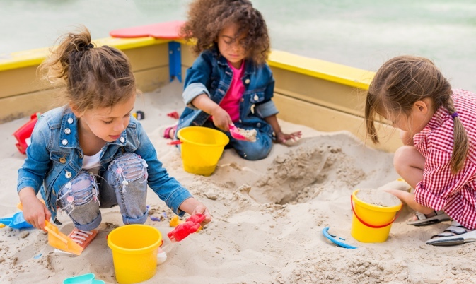

2020 Preschool Quality Improvement focus

What does this all mean?

Schools and Preschools develop a site improvement plan. These plans drive the learning improvement at a site (yearly or 3 yearly) which focuses on educator professional development, curriculum planning and assessment for learning. These plans also align with our River Hub Partnership priorities (other local kindergartens and schools)

This year are joint goals align with a focus on children’s literacy and numeracy with an additional site goal of further developing children’s empathy.

*Goal 1: To develop children’s secure sense of number to enable them to understand and apply mathematical thinking to their world.*

*Goal 2: To engage children in reciprocal conversations to enhance their oral language development.*

*Goal 3: Support children’s increasing capacity to successfully engage with others and the learning program by developing a strong sense of empathy.*

Information about these goals are documented in our 2020 Quality Improvement Plan, captured in children’s learning stories, children’s individualised learning plans and educator’s professional development plans.

How can you support your child’s development in these areas?

Parent information is shared via our newsletters, handy websites and in parent handouts.

Have a chat with educators if you would like information about how to further your child’s development in these areas to support their learning through into school or how we support your child’s learning through play in these areas.

FREE PLAY, FREE-CHOICE PLAY,   
CHILD-DIRECTED PLAY OR UNSTRUCTURED PLAY

**The importance of Free Play has been well researched. It is essential for all children to participate in Free Play. From their Early Years and throughout the Key Stages it plays a crucial role in their development.**

What is FREE PLAY: *Children choosing what they want to do, how they want to do it and when to stop and try something else. Free play has no external goals set by adults and has no adult imposed curriculum. Although adults usually provide the space and resources for free play and might be involved, the child takes the lead and the adults respond to cues from the child”*.

children are highly motivated to play! They want to know about the world around them, and they need to be in a caring environment that allows them to explore all sorts of concepts freely, whether academic or social. Most aspects of physical and cognitive development and learning come through play. Given plenty of time for Free Play, a child’s way of playing will grow in its complexity. This is what we love about it!

**FREE PLAY…**

* **Promotes Personal, Social and Emotional Development**
* **Encourages Cognitive Development and a Child’s Ability to Solve Problems**
* **Supports a Child’s Physical Development**
* **Enhances a Child’s Language and Understanding of Cultures**
* **Reinforces Classroom Learning**
* **Allows a Child to be Happy**

**National Quality Framework** | Quality Area 1:   
*Educational Program and Practice*Element 1.2.2 - Responsive teaching and scaffolding

Element 1.2.3 - Child directed learning

Homan, Emma. (2020, February 15). Why Free Play Is Crucial For Early Years Children. *Retrieved from* https://www.pentagonplay.co.uk/news-and-info/why-free-play-is-crucial-for-early-years-children

The Floor Is Lava

**Short simple activities to get some active minutes in the day.**

This is a simple game often lots of fun when surprised on those you intend to play with. Before you do play though, make sure the area you intend to play it in is free from breakables.   
  
To play, one person yells “The floor is lava!” and then starts counting down from five. Every other person must be completely off the ground by the time the counter reaches zero. What, they climb on is up to them, but if any part of them remains on the ground, then they’ll be burnt to a crisp.   
  
Continue the challenge by asking players to reach a certain place without touching the ground. Watch as each player creatively devises a plan for crossing the dangerous lava without burning their toes.

FRIEDA CORPE KINDERGARTEN  
Email: dl.3632_leaders@schools.sa.edu.au

Phone number: 83842108