Michelle DeGaris Memorial Kindergarten

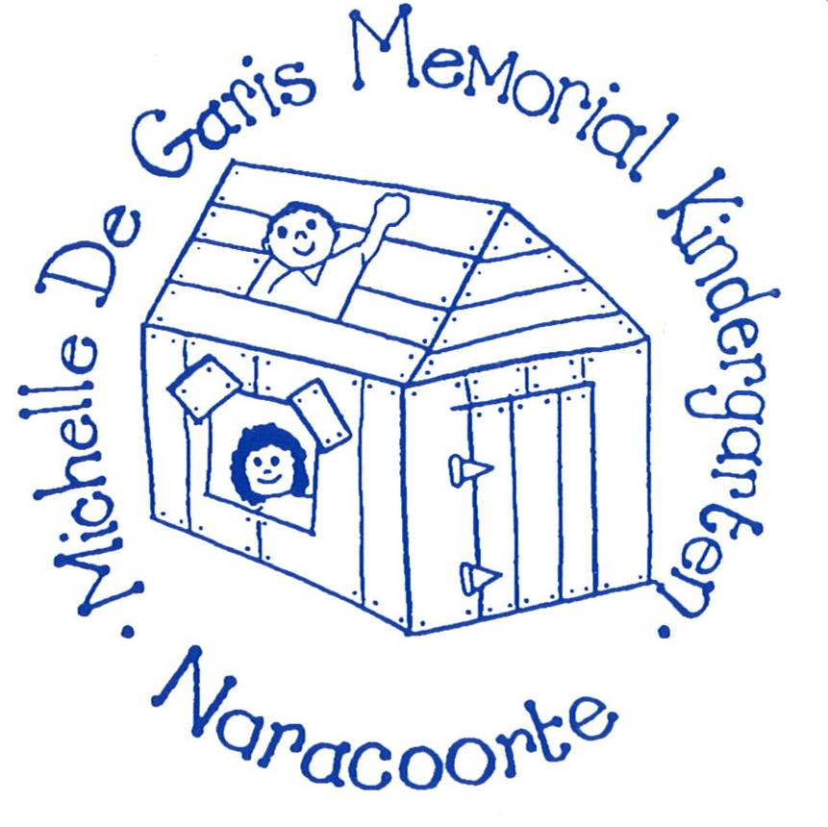

Information Handbook

Table of Contents
Contact Information
Staff
Our Philosophy
Available Services
Session Times
Fee Structure
Daily Routine
Attendance
Arrival and Departure
What to bring
Curriculum and Programming
Assessment and Reporting
Behaviour
Policies and Procedures
Student Health and Medication
Communication
Parent Involvement
Transitioning to school
Other Helpful Bits and Pieces
Support Service

Contact Information

Michelle DeGaris Memorial Kindergarten
10 Price Avenue
(PO Box 379)
NARACOORTE SA 5271
Website: michellekgn.sa.edu.au

Phone: 08 - 87 621 086
Fax: 08 – 87620 862
Mobile: 0409 621 086
Email – Geraldine.Mathieson0@schools.sa.edu.au

Staff

Director – Geraldine Mathieson
Teacher – Chantelle Weckert
Karissa Schultz
Early Childhood Workers (ECW) –Deb Krieger, Susie Sutherland, Meg Nolan, Deb Henschke, and Jayne Castine
Occasional Care Worker – Susie Sutherland
Bi-Lingual Support Worker – Sima Muhammadi

Governing Council Committee

Chairperson – Mon Crossling
Vice Chairperson – Chelsea Simcock
Secretary – Chloe Dix
Finance Manager – Bec Henschke
Book Club Co-ordinator – Eliza Mulraney
Occasional Care Representative – Belinda Manser

Our Philosophy

Michelle DeGaris Memorial Kindergarten

Our Place
We provide for Continuity of Learning through a pathway that starts with Playgroup to Occasional Care, then on to Pre-entry, Preschool, then onto School. There are many staff that crossover sites that assist in this process.
All current staff have a commitment through engagement with Michelle DeGaris Memorial Kindergarten through either having attended or children or siblings have attended.

We provide a flexible service to meet children and family’s needs.

Our Values
Our values are being
- Collaborative
- Respectful
- Supportive
- Creative
- Kind

Our Beliefs
We believe
Every child is unique, rich in potential and has a right to learn through play in an inclusive and respectful environment
Children are natural researchers who hypothesise, experiment, investigate, inquire and problem solve with and alongside others.
Children’s growth and learning is supported when they feel safe, engaged, challenged and have a sense of belonging.
When educators develop secure, reciprocal relationships they are able to provide meaningful, holistic learning experiences for all children.
When educators are committed to engaging in collaborative critical reflection and professional learning, they will effectively use their knowledge of and interactions with children to plan for and extend their learning.

Our Commitments
We will create an environment where each child feels a sense of belonging to confidently play, learn and grow.
We will facilitate collaborative inquiry learning to challenge and extend children’s thinking and promote their agency.
We will ensure that all educators regularly meet and engage in critical reflection and professional learning to improve pedagogy and practice.

Our Intentions
Educators will utilise a blend of Intentional Teaching, Child led Inquiry and Playful learning as
Co-Constructors of experiences.

Educators will implement improvements in Pedagogy and Practice into the everyday learning experience.

Available Services

Michelle DeGaris Memorial Kindergarten offers a range of programs for children from birth through to school age. These include -

Come and Play - parents, care providers, grandparents etc are welcome to visit Michelle DeGaris Kindergarten and join in with a variety of activities available on that day. Children can attend from birth until school age.
Occasional Care – children aged from 2 years are able to access 1 x 3 hour session per week when places are available. The Occasional Care program is facilitated by Susie Sutherland. Children are able to socialise with Kindy students while building their social and independence skills and participating in a range of play-based activities.
Kindergarten - most children are eligible to attend 4 terms of Kindergarten prior to starting school. Children can attend 15 hours per week which is made up of 2 days per week plus ½ day every fortnight.

Session Times

Come and Play Monday, Tuesday, Thursday and Friday
10am – 11:30am and 1:30am – 3.00pm

Occasional Care (1 x session per week per child)
Monday 9am – 11.45am; 12.45pm – 3.30pm
Thursday 9am – 11.45am; 12.45pm – 3:30pm

Kindergarten
Monday; Thursday 8.45am – 3.30pm; and Wednesday week 2 9.00am – 12 noon OR
Tuesday; Friday 8.45am – 3.30pm; and Wednesday week 1 9.00am – 12 noon
Michelle DeGaris Memorial Kindergarten offers a bus service for eligible students on Tuesdays and Fridays. A staff member meets bus children at Naracoorte Primary School and travels with them via the link bus to Kindy.

Fee Structure

Come and Play $2 per session

Occasional Care $5 per session, $2.50 for siblings
$1.50 per session, 75c for siblings (Healthcare Cardholders)

Kindergarten $80.00 per term
One off fundraising fee $20 (due Term 1)

Fees can be paid either by cash, cheque or direct deposit to Michelle DeGaris Memorial Kindergarten.
Banking details are as follows –
BSB 065 506
Account No 009 00367

NOTE: Please use your child’s name as a reference.
If your family has difficulty in paying fees, please see the Director to make an alternative arrangement.

Daily Routine

Children are most successful in an environment which is familiar and where expectations are understood. At Michelle DeGaris Memorial Kindergarten we aim to follow a consistent yet flexible daily timetable. These times are approximate to other elements in the day.
8:30 am – 9:00 am Children arrive and prepare for the day
9:00 am Free play – inside and outside
9:30 am Morning Mat time (Pre-Lit Literacy Session)
10:00 am Healthy snack
10:30 am Numeracy Learning Groups
Free play
11:30 am Pack up
12:00 pm Lunchtime
12:20 pm Relaxation Time
1:00 pm Free play
1:30 pm Learning Intentions Groups and Teaching Sprints
Free play
2:30 pm Pack up
3:00pm Mat time
3:30pm Dismissal

Attendance
Children are strongly encouraged to attend ALL eligible Kindy sessions when possible. This is particularly important during certain weeks (usually 1, 2 and 3) of each term when attendance data is collected. This data is vital for ensuring future funding for the Kindergarten. Please advise Kindy staff of any absences. The Department for Education (DE) requires that all absences be explained either in person or via phone or written note.
Please ensure that you notify Kindergarten staff of any changes in your family’s circumstances such as change of address, phone, family structure etc. It is also essential that emergency contact information is up to date in the event that you are unable to be contacted.
For more information refer to the Attendance Procedure via the website www. michellekgn.sa.edu.au or ask Kindy staff for a printed copy.

Arrival and Departure
As soon as you enter our site, please either scan our COVID-SAfe QR code, or sign in manually. This is a current direction under the Emergency Management Act 2004.
Upon arriving and departing ALL children must be signed in and out by a parent / caregiver as a legal requirement. No child will be permitted to leave with an adult other than those nominated unless prior notice has been given to staff.
We ask that all drivers exercise extreme caution when driving in and around the Kindergarten during drop off and pick up times. Please also note the 25kph speed limit when driving past.
Please take note to ensure the gate is securely closed behind you as you enter and leave the grounds.

What to Bring

Each day your child attends Kindergarten they will needs to bring –
- A clearly labelled bag including bag tag
- A named drink bottle (water only please)
- A healthy snack
- A labelled lunchbox with lunch and snacks for the day
- A suitable sun hat (all year round) – wide brimmed or bucket hat
- Take Home Folder (Communication book if travelling via bus)
- A labelled change of clothes
- Nappies if required
PLEASE NOTE: Due to children with allergies, we are a nut and egg aware Kindergarten. Please DO NOT send these foods with your child.

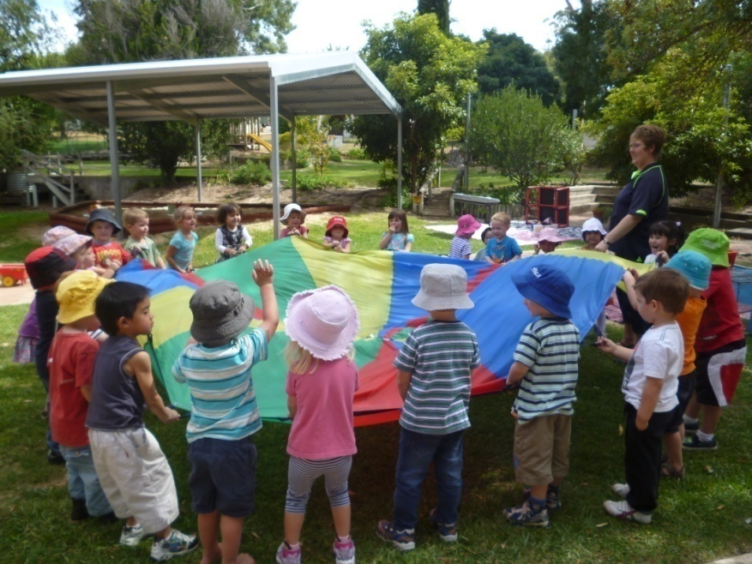

Curriculum and Programming

At Michelle DeGaris Memorial Kindergarten, our educational program is based on the Early Years Framework – Belonging, Being, Becoming – as required by the Department for Education (DE).
The Early Years Framework is based on 5 key outcomes. They are –
- Children have a strong sense of identity
- Children are connected with and contribute to their world
- Children have a sense of well being
- Children are confident and involved learners
- Children are effective communicators
Each term a focus topic is chosen. This forms the centre of educational activities in which the children participate. In addition to this planning and assessment operates in a cyclic rotation depending on the student needs identified by Kindergarten staff.

Assessment and Reporting
Assessment of student learning and development takes place in both formal and informal ways.
A record of your child’s time is kept in individual Learning Journey folders. You are welcome to view this at any time. These folders are located in the locker area under the floorbook. This folder contains your child’s work samples, educator observations of your child’s learning, photos and experiences throughout their kindy year.
Please do not hesitate to approach Gerry or Channy with any questions regarding your child’s progress at Michelle DeGaris Memorial Kindergarten BUT this is a 2-way process. It is vital to inform staff of any factors which may influence your child’s behaviour or development at Kindy.

Behaviour

At Michelle DeGaris Kindergarten BOTH children and staff have rights regarding appropriate and acceptable behaviour. Rules help us to respect our rights and the rights of others and to encourage responsibility.
We believe that children have the right to learn and play in a friendly, safe and supportive environment.
We believe that staff have the right to teach in a friendly, co-operative and supportive environment.
There are 3 main behaviour codes surrounding communication, learning and safety. Logical and appropriate consequences are in place for times when rules are not followed.
For more information refer to the Behaviour Code via the website www. michellekgn.sa.edu.au or ask Kindy staff for a printed copy.

Policies and Procedures

Safe Centre Procedure
Aim
- To establish and maintain a safe and supported environment for children, families and staff
- To identify and appropriately deal with bullying, harassment, violence and child protection
Implementation
- Follow the 9 key elements of the National Safe Schools Framework
- Be aware of different types of bullying and how to manage them
- Teach the Keeping Safe Child Protection Curriculum to an age and developmentally appropriate level

For more information refer to the Safe Centre Procedure via the website www. michellekgn.sa.edu.au or ask Kindy staff for a printed copy.

Skin Protection Procedure
Aims
- Promote skin protection awareness to children, parents and staff
- Promote a positive attitude and personal responsibility toward skin protection
- Show how changing our lifestyle and protecting our skin can help reduce the incidence of skin cancer
Implementation
- Wear sun safe clothing
- Apply broad spectrum 30+ sunscreen
- Restrict outdoor play during the hottest part of the day
- Adults act as positive role models
- Regularly update the Skin Protection Procedure

For more information refer to the Skin Protection Procedure via the website www. michellekgn.sa.edu.au or ask Kindy staff for a printed copy.

Evacuation Procedure
In the event of an emergency and an evacuation is required, children, staff and visitors will assemble on Memorial Oval or near the Table Tennis Hall.

Grievance Procedure
Parents and caregivers with issues regarding their child/ren at Kindergarten are advised of the following procedure to rectify the situation –
- Raise the concern with the Centre via telephone or in person
If solved ..... Great
If not .....Then
- Make an appointment to see the Director. Inform them of the situation and who is involved.
If solved ..... Great
If not ...... Then
- Contact the Regional Director at the Limestone Coast Regional Education Office (Ph 87 245 300).

- Contact the Parent Complaint Unit (Ph 1800677435).

For more information refer to the Grievance Procedure via the website www. michellekgn.sa.edu.au or ask Kindy staff for a printed copy.

Hot Weather Procedure
All of the programs at Michelle DeGaris Memorial Kindergarten pay particular attention to strategies aimed at reducing the risk of heat illness in younger children. Some examples of these strategies are:
- Shade activities conducted in periods of hot weather
- Children are frequently offered water to drink and water is accessible at all times
- Parents are encouraged to dress children in sunsafe clothing that minimises heat gain
- Parents are encouraged to pack food in insulated containers with a freezer brick.

Health and Medication
Many children attending Michelle DeGaris Memorial Kindergarten require medication and/or specialised health care while at Kindergarten.
Kindy staff will advise parents / caregivers of the required Health Care forms which need to be completed. The information provided is specific to your child’s medical condition.
ALL medication to be administered at Kindy needs to be -
- handed to a staff member
- in the original packaging
- in the measured dose
- authorised by signing a consent form

Communication
Parents / caregivers are encouraged to contact staff with questions or concerns regarding their child’s learning and wellbeing at Kindy.
Information about Kindergarten matters are conveyed to parents / caregivers in a variety of formats and will usually be emailed and/or in your child’s Take Home Folder. These include –
- a fortnightly newsletter
- 1:1 conversations either in person or via telephone
- Learning Journey Folders
- Emails
- Facebook page (Michelle De Garis Memorial Kindergarten)
- Home visits (if required)
Please empty and return your child’s Take Home Folder each session.

Parent Involvement

Parents / caregivers are encouraged to be actively involved in their child’s pre-school education. Throughout each year, there are many ways to do this. They include –
- Helping at home (ie cutting fabric, colouring pasta etc)
- Volunteering to help at working bees and excursions
- Joining the Governing Council
- Helping with end of term cleaning
- Washing smocks and tea towels as per the roster
- General participation at all times

Governing Council meetings are held twice a term on a Wednesday mornings. Curriculum Committee meetings are scheduled when needed. Meeting dates are advised through the newsletter and via email.

Transitioning to school

Michelle DeGaris Memorial Kindergarten maintains positive relationships with all local primary schools in the Naracoorte and district area – Naracoorte Primary School, Naracoorte South Primary School, Sunrise Christian School Frances Primary School, Lucindale Area School, Apsley Primary School and Edenhope College.
To assist your decision, it is best to arrange a meeting with ALL possible options in regard to the school structure that best meets the needs of your family. Please talk to a staff member if you have questions regarding your choice of school.
To ease the move from Michelle DeGaris Memorial Kindergarten into primary school, a transition program will take place in Term 4.

Other Helpful Bits and Pieces
Uniform – Iron on logos are available to purchase for $2 from the Kindergarten. As children are actively engaged in a range of inside and outside activities, we encourage them to come wearing ‘older clothes.’ Suitable footwear is also required.
Book Club – Usually available once a term for those wishing to purchase books. Completed order forms are to be returned to Kindy or via the Bookclub app by the due date with payment.
Library – Children and parents are welcome to borrow a range of fiction and non-fiction books from the Kindy library.
Lost Property – Please ensure ALL of your child’s belonging are clearly labelled. Un-named items are placed into lost property in the basket under the sign in sheet.
Payments – All money is to be handed directly to a Kindy staff member in a sealed envelope which includes your child’s name and what the payment is for. Alternatively, some payments can be made via direct deposit. Please also include your name and details about the payment and provide staff with a printed receipt.

Support Services

Additional support services are available to eligible children who attend Michelle DeGaris Memorial Kindergarten. Some services operate during Kindergarten hours while others are available in the local Naracoorte community. Children are able to access additional support such as speech therapy, occupational therapy, English as a Second Language (ESL) support, physiotherapy, dental service and Child and Youth Health Service (CAYHS) depending on individual needs and availability.

