

Kathleen Mellor Preschool Kindergarten
51 Bowen Rd Tea Tree Gully 5091
Ph: 82643603
Mobile: 0427076189

Website: www.kathmellkgn.sa.edu.au
FaceBook: www.facebook.com/kathleenMellorKindergarten

NEWSLETTER No. 7 16th September 2020
KINDY DISCO- Friday the 10th of September | Social Distancing
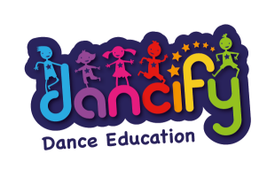  Practices begin soon for the kindy disco!  ‘Dancify’ will be coming to teach the children some dances to show you at the kindy disco.  There is a cost involved with these lessons and a consent form and note is overleaf. It is $25.00 for the 5 lesssons.  Please make sure you can come to the disco on Friday the 10th of September at 6.00pm at the Tea Tree Gully Primary School Activity Room. The children will be voting on the theme for the disco and we will let you know what they decide in case there are costumes involved!!  The kindergarten has lots of costumes that you could borrow if you don’t have any at home.  Due to Social distancing restrictions the disco will be limited to immediate family, no grandparents, aunties etc. Siblings are welcome.  Pizzas for dinner  This year, due to COVID 19 restrictions, we are planning to have pizzas for dinner that you will order and pay for prior to the night.  Each order for your family will be an individual order, so there is no sharing of food. We are going to order the pizzas from Pizza Bite at Redwood Park and they will deliver them to us, at the school at 6.30pm.  The menu is on Facebook, just search Redwood Park Pizza Bite.  If you do not have access to Facebook, let us know and we can print the menu for you. Once you know what you want to order, please fill in a form (that will be sent home soon) and return it to kindergarten. Money for the pizzas must accompany your order.  Donations needed  We intend to have a raffle on the night to raise some funds.  If you have contacts with any businesses that you think would be able to donate a prize or a voucher for the raffle, please see Anne to get a letter to give to the business.  If you don’t have any contacts but are able to donate something yourself we would love any donations you are able to give.  Wine, chocolates, specialty biscuits, anything that you would like to receive in a gift basket.  I wish Excursion…..  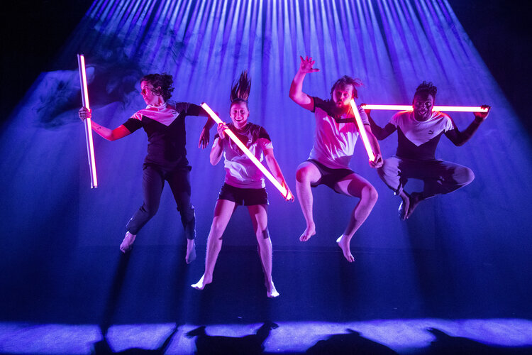  Please return your consent forms for the excursion asap, as I need to confirm numbers with the venue. | Thank you so much for your co-operation in maintaining social distancing. We know that some of you miss coming into the kindergarten to see what we have been doing. If you would like to have your child’s profile folder brought home at any time, just let us know and we can give it to them at the end of the day.
Governing Council
At the Governing Council meeting last night the Council approved a Pupil Free Day for Thursday the 16th September, which is week 9 of the term.
There will be no kindy on this day as staff are doing some professional development.
Diary Dates
Thursday 5th August: Bush kindy with Shanelle
Wednesday 18th August: Dancify dance lessons commence
Thursday 19th August
“I wish” performance at the Space Theatre
Tuesday 31st August: Governing Council meeting at kindergarten
Friday 10th September : Kindy Disco
Thursday 16th September”: PUPIL FREE DAY - NO KINDY
 | 

Kathleen Mellor Kindergarten
51 Bowen Road, TEA TREE GULLY 5091
Telephone: 8264 3603 Fax: 8395 3607
dl.4626_leaders@schools.sa.edu.au www.kathmellkgn.sa.edu.au

Dear Parents / Caregivers,
Dance lessons at kindy!
Erin from ‘Dancify’ has been booked to come to the kindergarten to run dance lessons in preparation for the kindy disco. These lessons have an emphasis on building self confidence, creativity, body awareness and most importantly, self esteem in young children. After the lessons children are more aware of their bodies, more flexible and more confident in dancing.

Erin will come for 5 sessions and she will also attend the kindy disco to help the children remember the dances!

Please place $25.00 in an envelope with your child’s name and ‘dance lessons’ on the front and place in the fee box.

Thanks,
Anne

Please sign the consent form below to give permission for your child to be included in the dance programme.

…………………………………………………………………………………………………

I give permission for ……………………………………. To be included in the dance program at kindergarten in term 3 and 4 in preparation for the kindy disco.
I enclose payment / I have transferred the amount of $25.00

Signed…………………………….Parent/Caregiver

This can be paid via Direct Deposit. The Bank details are:
BSB: 065 149
Account Number: 00901707
Account Name: Kathleen Mellor Pre-School Kindergarten Association Inc.

Please quote Child’s Initial & Surname as reference.
Pease check account number etc. as it is your responsibility to make sure the payment goes into the correct account. ☺

