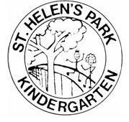

October Newsletter 2020

Welcome back to Term 4! We hope you have had a restful and happy break in the holidays and refreshed before the rush to Christmas. We know this term will pass quickly and there will be much excitement as we prepare for the end of the year and start the transition process to school. This year we have had many challenges and we appreciate your support across this. Unfortunately it looks likely that the children will not experience an excursion at this point however we have now been able to invite performers in to the site. We are very excited also to have organised a favourite curriculum opportunity of hatching chicks with our Living Egg program. This will begin next week and run for 2 weeks. At it's conclusion we will have chicks to give away. If you are interested in raising chickens please see staff. You are required to take at least 2 chicks but we do not guarantee hens! tTey can be roosters!! Annette can give you advice about raising chickens so don't hesitate to see her.
Don't forget to sign in your child on arrival please, or remind staff to tick them off if you are dropping at the gate; we have a new administration system and the paperwork has a different format.
Over the next 5 weeks staff are preparing reports for the schools to assist in transition to Reception. These summative statements will be part of your child's portfolio that is presented at the end of year celebrations. I am currently negotiating with Prospect Council about a picnic in the park as we do not have enough room in our yard to host our end of year celebrations safely under COVID rules. We have scheduled Wednesday November 25 (group 1) and Thursday November 26 (group 2) for this from 5.30pm, and will have early dismissal from kindy at 2.30pm so your child can have a rest before returning to participate in a small ceremony and presentation. I will keep you posted on developments!

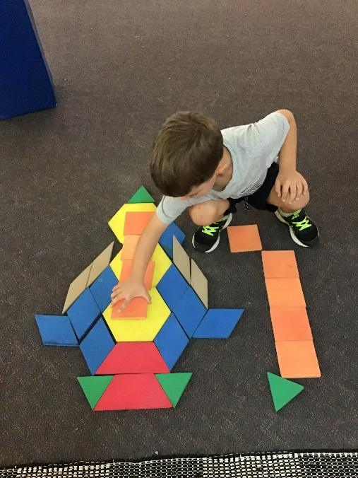

CAR PARK
Please be aware of the tight parking situations we are currently experiencing. We have had several incidents this week of people not following road rules and parking illegally which has caused distress to other road users. Council often has inspectors out so please be aware that you might get a fine!

Curriculum
Our focus this term is on children's wellbeing and resilience in moving forward into exciting learning opportunities at school. We understand that for many children this holds mixed emotions and it can be a challenge for them to cope with such change. Whilst they appear excited at becoming 'big school kids' it can cause hidden anxiety in going to strange environments where there will be more than 100 children in the yard and new children in the class. It is not unusual for them to be emotional, not sleep well or show changes in behaviour. Our emphasis is on the similarities of kindy and school- we ring a bell for transitions, we have recess and lunch where the children look after their possessions; we have writing activities, teaching times, encouraging children to be organised about toileting and drinks before coming to teacher time just to name a few. We have a strong focus on resilience- finding an answer to a problem or seeking help, staying calm and thinking about strategies that could work.
Our term topic is Our Body and we will be exploring how our body works. Each week the children will engage with a different organ and investigate how it relates to our health. We will be looking at hearts, lungs, stomachs and brain in particular and will have some organs from sheep to see the real thing (children do not have to touch!). We would also love to hear from any new Mums who could bath their baby at kindy so we can look at body differences- please see Sue if you are interested in participating in our learning program.
A big thankyou to our parents who have joined us already this year- Matilda's mum for Nature Education and Roses's mum as back up!; Una's dad for cooking pizza; our wonderful cooks with biscuits; Lucia's dad for sharing his garden knowledge; Laurence's Grandpa for origami; all of our lovely parents for washing; anyone who has helped with cleaning; management committee for meeting regularly and guiding the kindy in finances and upgrades; and anyone else who has been a support to both staff and children.
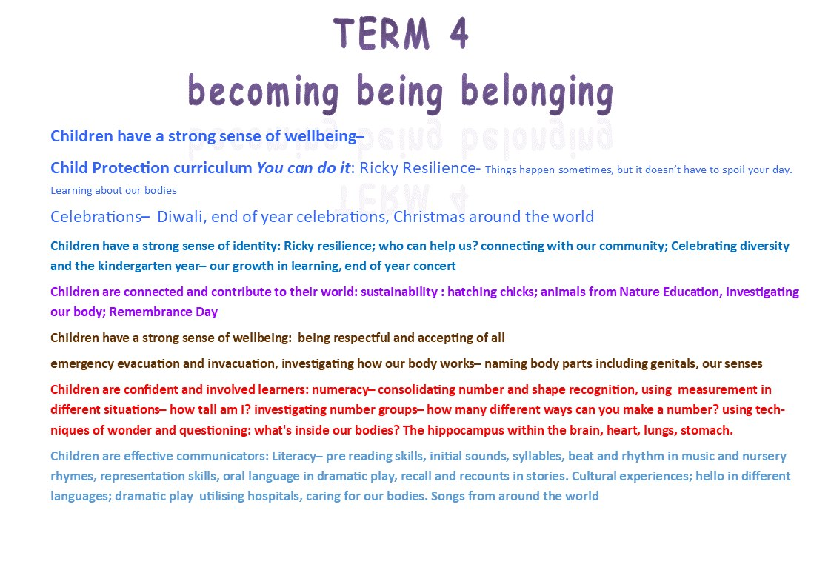

CLOSURE DAY Thursday NOVEMBER 5
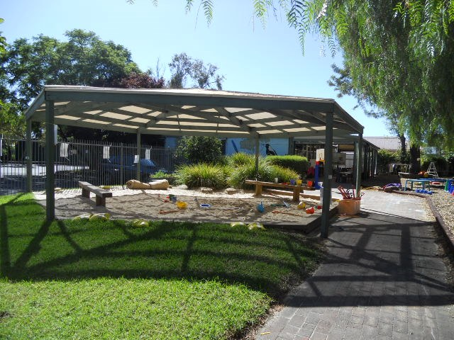
Kindergarten will be closed on Thursday November 5, as already notified, for review of the year with our Regional Team. we will be meeting with all the kindergartens in our area to showcase the learning on site and to plan for future improvements.

Term Dates
Term start- Mon Oct 12
Book Week- October 20 & 21 with Prospect Library (we do not have a dress up day)
Governing Council meeting- Tuesday October 20
Living Eggs - from Monday October 19
World Teacher Day- Friday October 30
Podiatrist- Tuesday November 3 and 4: children can have their feet and walking checked for free, (permission slips to come)
Diwali- Saturday November 14; activities on Monday 16 and Tuesday 17 November
Governing Council meting- Tuesday November 17
End of year celebrations- Wednesday November 25 and Thursday November 26 - to be advised
Term ends- Friday December 11 (this is a cleaning day and we would love your help!)

