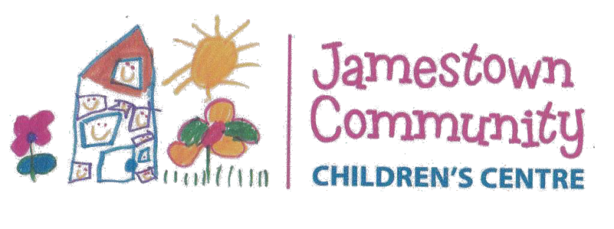
1a Cockburn Rd, Jamestown
PLAY IS OUR WORK
PH: 86641276
dl.6624.leaders@schools.sa.edu.au www.jamestownpre.sa.edu.au

Skin Protection and Hot Weather Policy

Rationale

- The Sun’s ultraviolet (UV) radiation is both the major cause of skin cancer and the best natural source of Vitamin D. In Australia we need to balance the risk of skin cancer from too much sun exposure with maintaining Vitamin D levels. The body needs vitamin D for healthy bone development and maintaining musculoskeletal health.
- Children are at greater risk of suffering from heat-induced illness than adults.

Strategies, Practices and Procedures

1. SKIN PROTECTION
THIS POLICY IS TO BE IMPLEMENTED AT ALL TIMES when the UV radiation levels for Jamestown are forecast to be 3 and above. Refer Sunsmart app:https://www.cancersa.org.au/cut-my-risk/sunsmart/resources/sunsmart-app-and-widget)
- Hats are to be worn outside. Hats should be broad-brimmed, legionnaire or bucket style with a deep crown and minimum brim width of 5cm for children 0-5 years and 6cm for older children and adults.
- Children are encouraged to wear shirts with collars and elbow-length sleeves and longer-style shorts/skirts/dresses.
- Minimum SPF 30+ Broad spectrum, water resistant sunscreen will be applied 20 minutes before children go outside and reapplied every 2 hours or more often if outdoors for extended periods or during water activities.
- Caregivers are encouraged to apply sunscreen to their children before coming to the centre.
- Where a child has a skin sensitivity to sunscreen, caregivers are asked to supply the child’s own sunscreen (named and in its original container).
- Where possible, outdoor activities will not be scheduled during peak UV times (over the middle of the day) and staff will be guided by the daily sun protection times. Shade will be utilised at all times unless the UV levels are below 3.
- The availability of shade will be considered when planning excursions.
- The centre will regularly review the adequacy of shade in the outdoor environment, with a view to planting shade trees and/or erecting additional shade structures.
- Babies under the age of 12 months will be kept out of direct sunlight as much as possible and will always be protected by hats, clothing and shade. Sunscreen will only be applied to those areas of skin not protected by clothing or shade.
- The sun smart message will be included in the curriculum and promoted to families via newsletters etc.
- Educators and visitors to the centre will act as role models by following the skin protection and hot weather policy.

2. HOT WEATHER
The following strategies will be undertaken in periods of hot weather:
- Shade: Activities are to be undertaken in shaded areas or moved inside.
- Drinks: Children are to be offered water frequently.
- Clothing: Caregivers are encouraged to dress children in clothing that minimises heat gain and in layers that can be easily removed. Staff will monitor children’s clothing and remove layers as necessary.
- Lunches: Lunches will be stored in the fridge and returned to the fridge if any uneaten food remains after meal times.
- Play equipment and surfaces: All play equipment and surfaces are to be tested before children are allowed access. If the surface cannot be comfortably touched with the palm of a hand for a slow count of five, the surface is not safe for children to play on.
- Power interruptions / mechanical breakdown: Should air conditioning fail, children will be offered quiet activities and encouraged to drink water frequently. In the event of power outage or breakdown, fridge temperatures will be monitored and once the temperature rises above 4 degrees, perishable foods must be consumed within 2 hours or discarded. Where lengthy power outage or mechanical breakdown prevents the service offering a suitable environment for care and education (in terms of temperature, lighting and/or safe food supply) caregivers will be contacted by phone and asked to collect children or to organise the collection by an authorised person.

This policy will be reviewed annually to ensure the policy remains current and relevant.

Approval Signatures:

Governing Council Chairperson Director Date

Policy Created/ Reviewed Term 4 2016
Reviewed: Term 2 2020
Next review date: Term 2 2021

