Woodside Preschool  NEWSLETTER | 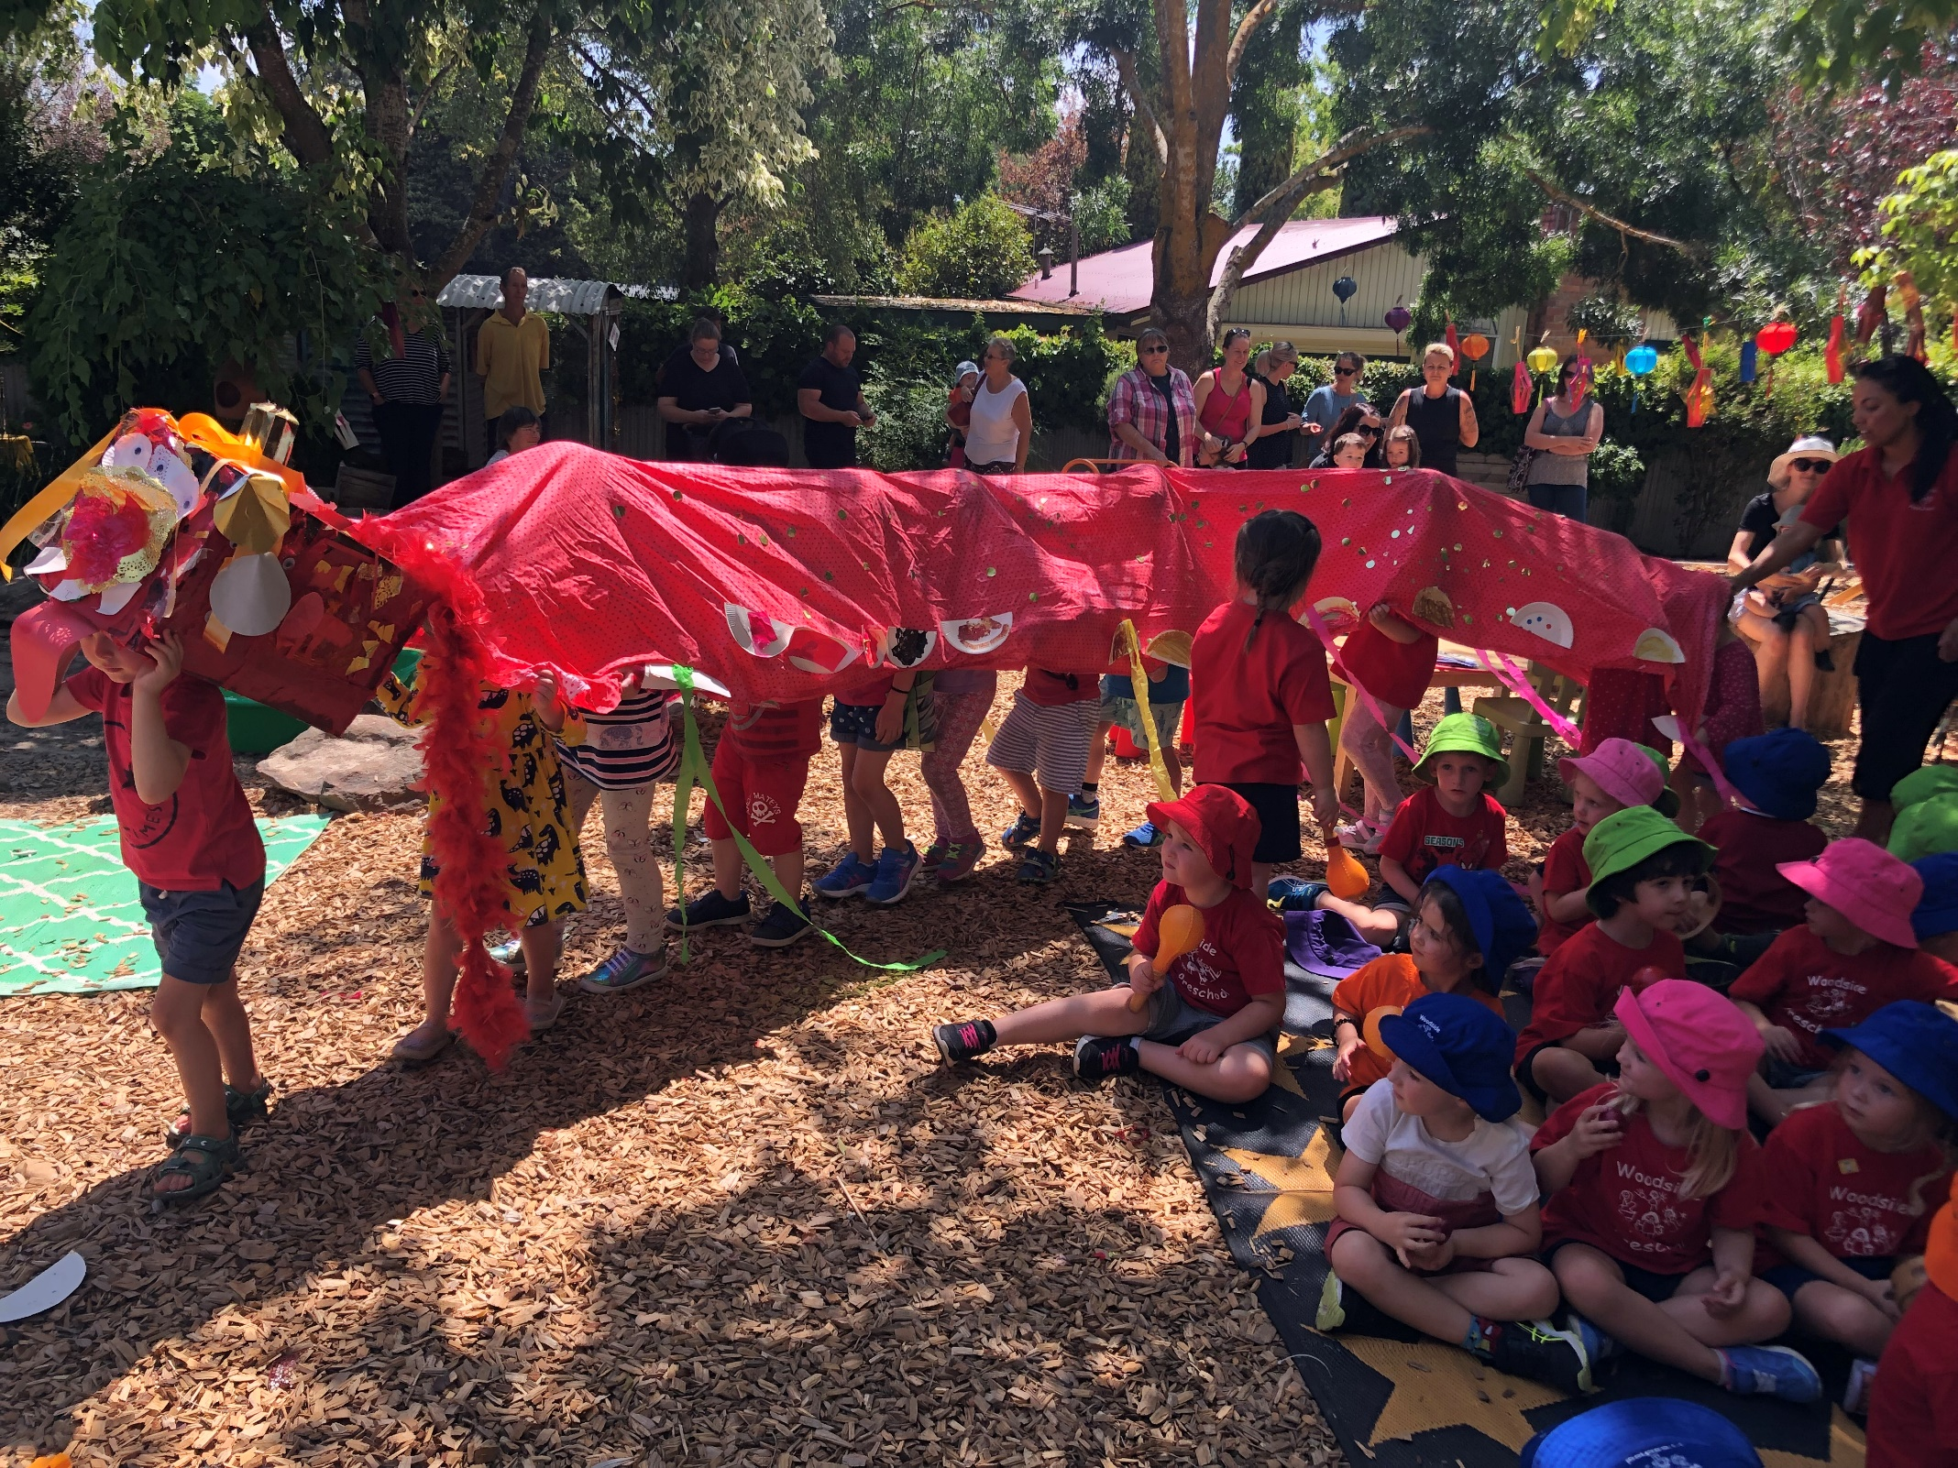
INSIDE
THIS
ISSUE
PG. 2
From the Director
PG. 3
What have we been learning?
PG. 4
Occasional Care News
PG 5
Governing Council News
PG 6
Snippets
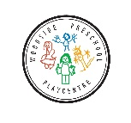www.woodsidepre.sa.edu.au  dl.4676_leaders@schools.sa.edu.au  12 Moffet St Woodside 5244  83897103  0409684855 | Diary Dates Week 9 Term 2 2018  FEBRUARY 19th Library  20th Mobile Junk  MARCH 5th Governing Council 7.30pm Library  13th Curriculum Night ( 7.00-8.30)  19th Library  21st Pupil Free Day- no sessions  APRIL 9th Governing Council mtg 7.30pm
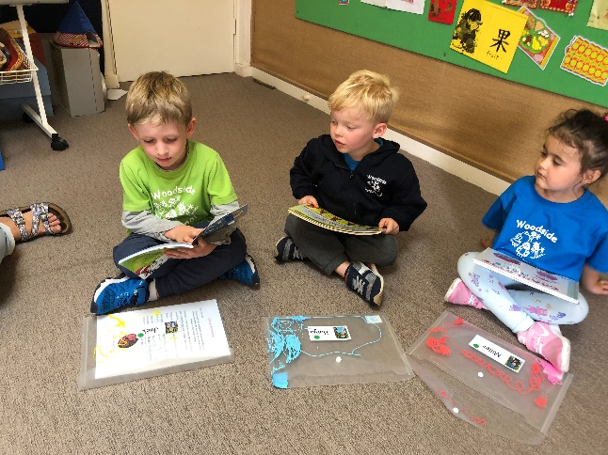
Robyn’s News

Developing COnfident COmmunicators
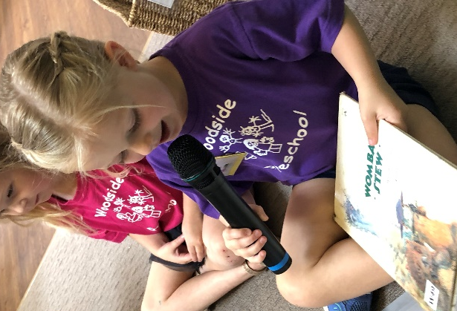
You will hear a lot about the development of Oral Language skills at kindy this year. Oral language is one of the most important aspects for successful readers (and writers) to develop prior to reading and writing. Before learning letters children need to be able to hear, separate and manipulate sounds, they need to experiment with words, syllables and rhyming and to develop as engaged and attentive listeners.
We will be sharing more information with families about our work in this area and how you can help at our Curriculum Information Evening later in the term. ( March 13th 7-8.30pm)
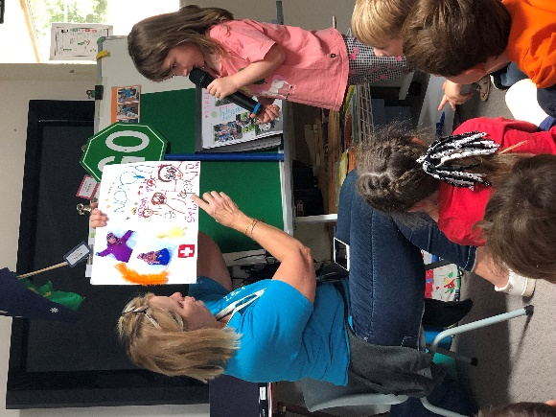
Some of the ways we support Oral Language skills:
Each week we have borrowing of library books on Tuesdays. As we change the books each week children have the opportunity to share with their small group something they enjoyed about the book they have had and they are then making choices about which book they would like next. In their book folder you will find a ‘cheat sheet’ that might give you some ideas of questions and discussions to extend the learning form the book. It is also great to read each book more than once so please hold onto the book for the week and re-visit it a few times
(You will find more about how you can support this later in the newsletter)
At our group time we have been learning each other’s names by using the microphone to say ‘Good Morning ‘ or share information and learning. This simple activity is helping to develop a sense of belonging, as well as confidence, oral language and listening skills.
Denise is our Gardening Guru and this year, as well as our bi-lingual veggie garden we will be learning more basic Spanish ( like counting and colours)! Not only are the children learning names of plants and gardening terms in English, but they are also being introduced to Spanish words as well. We have already noticed an interest in this with some of the children who have siblings learning Spanish at school.
Our ‘Daily Safety Officers’ have an important job to do and throughout the year every child will have a number of turns. Their role is to follow the visual checklist (either inside or outside) and report back to the group about the safety of the Kindy (swings up, gate closed, chooks fed, locker area tidy etc.).
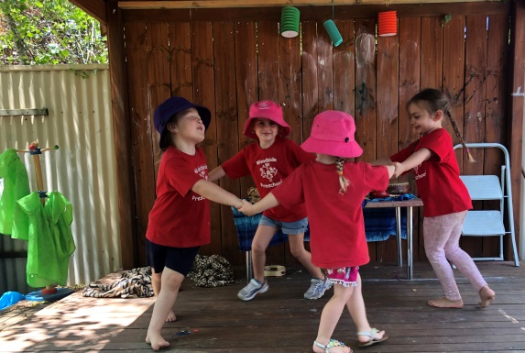
Our Learning

Our LEarning
Our first term is well and truly underway and we are well on our way to deepening our sense of belonging here at our Kindy. Children have been learning new routines and establishing new relationships with their peers and teachers. They have been adapting wonderfully to all the new information and working as part of a group.
Family pages, child profiles, sharing books and interviews with each child have given us a good understanding of where our children are coming from and what our goals will be for 2019.
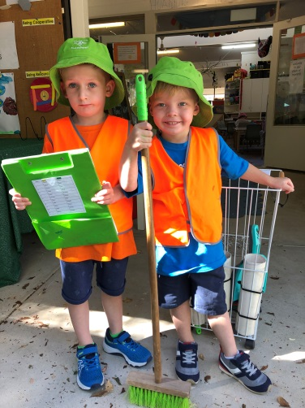
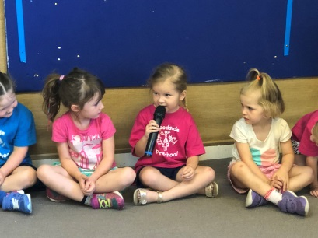
We have had some wonderful shared experiences with our Family picnic and Fritz the clown performance, and our Chinese New year celebrations.

Children have been excited to participate daily in the important roles of bell ringer, safety officers and discovery table officers. And we have been working hard at learning what it means to share a learning space;
- Taking care of our belongings
- Sharing learning resources and equipment
- Taking turns at speaking at mat times
- Learning about red and green choices in our play
- Helping with our jobs at pack up times
- Being organised and learning to be independent.
So much learning is going on every day,is it any wonder they go home very tired?? Other highlights of the term so far include; Using instruments and dancing
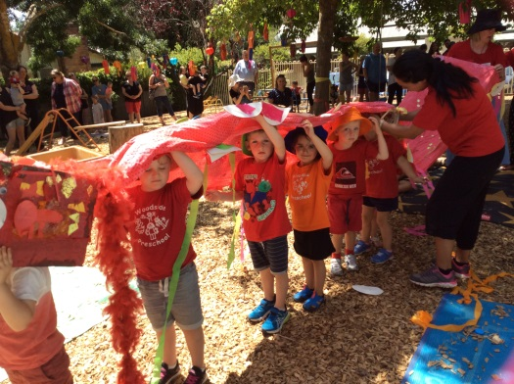
- Building and construction in our sand pit
- Our Mobile Junk Yard experience
- Visiting the School library
- Exploring Fruits and Vegetables using our senses.
We look forward to many more exciting adventures this term.
Sayonara – Kathy, Jodie & Jane
Occasional Care News NewsNews

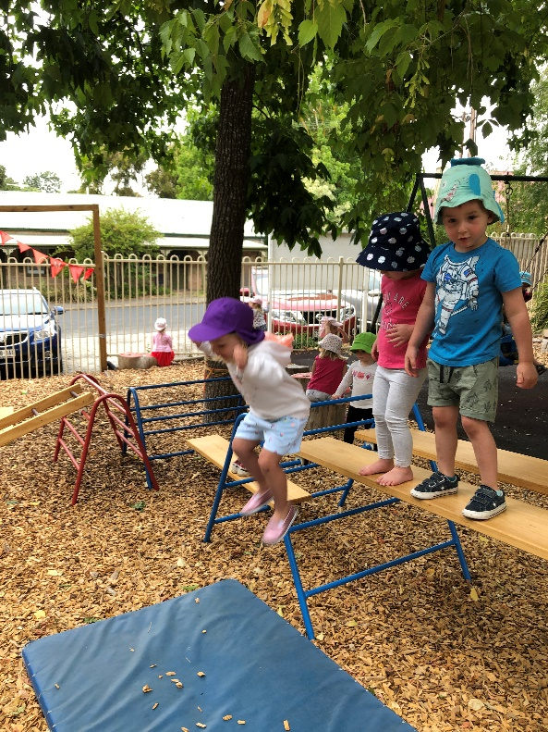
Occasional Care has started the year well with a huge number of children accessing the program. Obviously brand new children sometimes take a little while to settle in and can be upset at separation time. Be assured that this is normal and Jane and Tash are very used to settling children and helping them feel safe and happy in the centre. The important thing for you to do is to keep the routine the same, keep the goodbyes short and sweet and leave promptly after saying goodbye. Rest assured, if your child is distressed during the session we will call you to arrange an early pick up. You are also welcome to call the centre 20 minutes after leaving to check if your child has settled (often they are fine by the time you get to the gate).
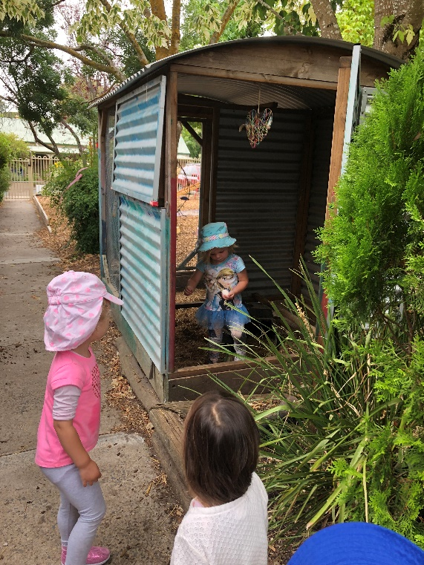
We try to regularly put Facebook posts up showing what the children get up to during the session. We also have a Floorbook, where we record photos and learning outcomes, favourite activities and plans for future sessions. This is on display near the sign in sheet and I encourage you to have a look through to see what’s been happening.
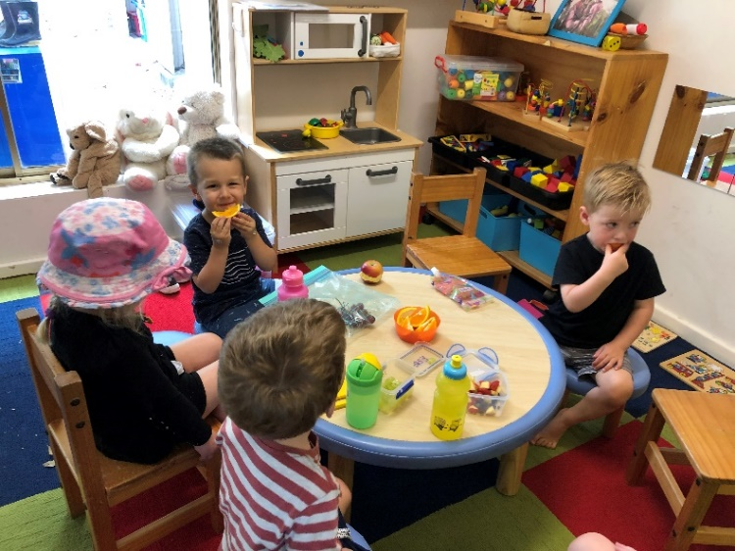
A quick word about dummies. You may have noticed that we don’t encourage the use of dummies during the occasional care session and the children are accustomed to handing them over when they arrive! We believe by the age of 2 and 3 years, if a child constantly has a dummy in their mouth, their opportunity to develop speech as well as interact with other children and adults can be impaired. All children in our program happily hand over their dummies to be put in their bags while they are at Occasional Care. We’d encourage you not to automatically fish it out and pop it back in their mouth when you arrive to pick them up. If they haven’t needed it for the last 3 hours they probably don’t need it now!
Encourage your child to chat to you in the car or have a snack or a drink instead of the dummy. After 12 months, dummies are really best left for sleep, rest and comfort times. Occasional Care is the ideal time to start weaning your child off their dummy before they start Kindy.
If you need some tips for weaning off the dummy there are some great websites that can help.
raisingchildren.net.au
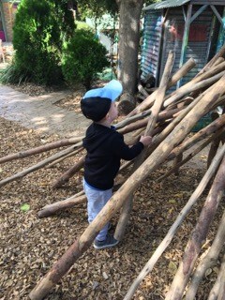
essentialbaby.com.au
www.mumsnet.com

Governing Council News

Thank You to everyone who attended our AGM last week. We had a great turn out, with lots of enthusiastic parents joining our Governing Council for the next 12 months.
Thanks also to our outgoing committee for all of their hardwork last year.
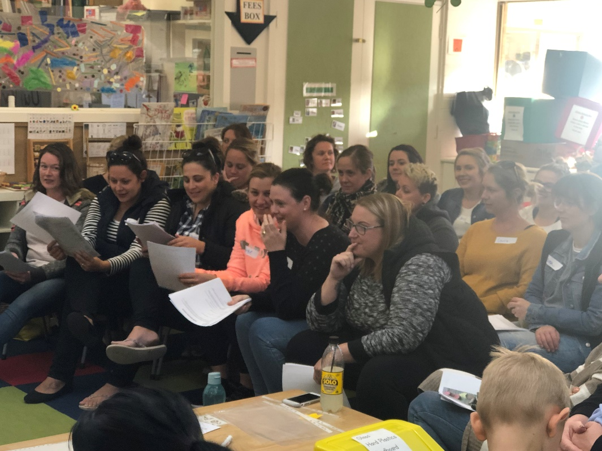
Your Governing Council for this year are:-
Chair- Jess Michalski
Secretay-Becc Tanner
Treasurer –Micha Sleep
Members- Belinda Martlew
-Laurice Pretty-Loriface
-Tracy Hogan (Playgroup Rep)
-Kiara Rundle
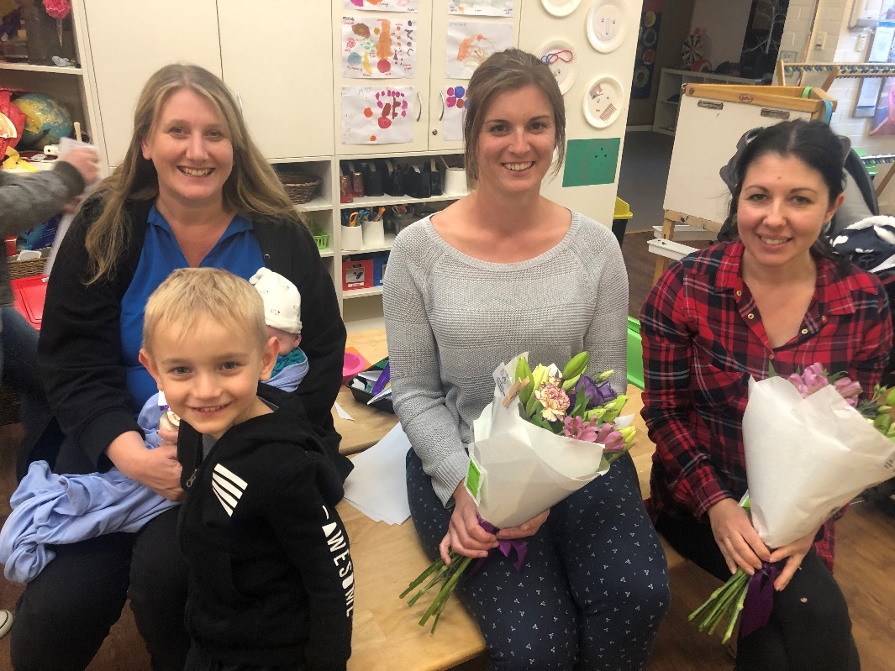
-Julie Gontar
-Jessica Edmonson
-Amelia Weston
-Yohanna Beltrame
- Emma Reid
-Katie Hart
-Kerry Penny
-Laura Giadresco
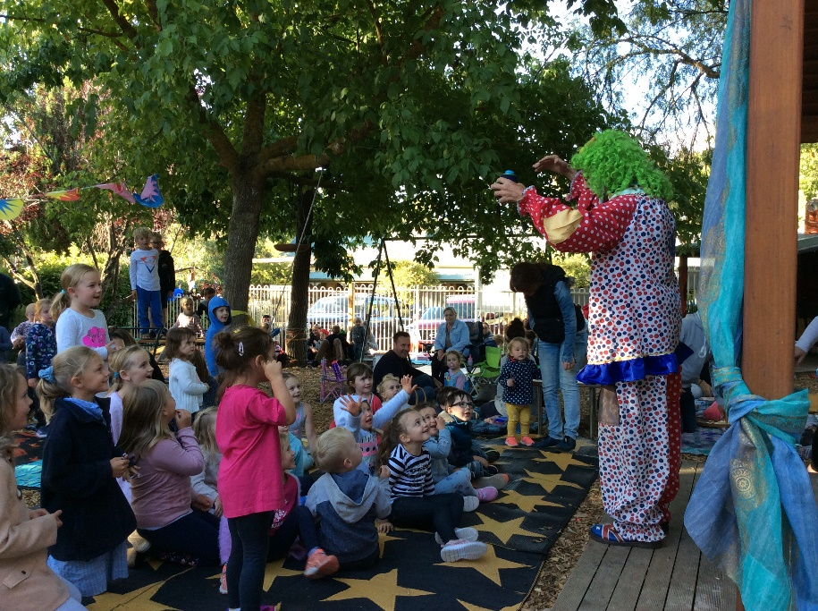
The first meeting will be held on Tuesday March 5th at 7.30pm

Snippets

Library
We have 2 Library Adventures at kindy this year and they both occur on Tuesdays
- Each week we will change over the library books for the children to take home. This occurs during our group time after lunch and is a time for us to share the books we have been reading and further our development of Oral Language through critical reflection, posing questions and public speaking. Please help your child to remember their book each Tuesday so that it can be changed over as part of the group experience.
- Once a fortnight we take a group of children to the Woodside Primary School Library where they have the opportunity to engage in a range of experiences including story time, using the computers, music and learning about the library. To make this a more meaningful experience we generally take ½ of the group on a ratoating basis.
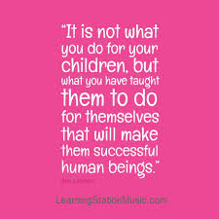
Capable 4 year olds
One of the mantras of the staff here is that children are competent and capable learners. One way we like to support this is by encouraging their independence to complete every day tasks all by themselves. Not only does this make them feel better about themsleves, it also frees you up- so why not give it a go?
Next week we would love it if you have the expectation that your child will carry their bag in by themselves ( it really isn’t too heavy for them!).
Once they get inside see if they know where to put their drink bottle, lunch box and bag. We are pretty confident that they will all be able to do it all themsleves!
( We know you will be tempted to carry their bag ,or even them, to the gate and then hand it to them when they get inside the gate. This actually demonstrates to the children that you don’t think they are capable of coping without you- turn it around and show them how proud you are of their independence.)
At the end of the day reverse the process and ask your child to collect their belongings before they go. Your support with some gentle hints about what they need to remember helps them to become independent and develop the skill of taking responsisbility for their belongings.

