What’s On Term 4 2019  160 Portrush Road,  Trinity Gardens  (enter via Devitt Ave) |  |  |  |  | Director: Catherine Day  CDC: Cathy Tomaselli  FP: Emma Gillett  Phone: 8333 2557  http:/www.trinitygardenscc.sa.edu.au/  info.cctrinity575@schools.sa.edu.au
Monday |  | Tuesday | Wednesday | Thursday |  | Friday
Preschool  8.30am- 4.00pm |  | Preschool  8.30am- 4.00pm | Preschool  8.30am- 4.00pm | Preschool  8.30am- 4.00pm |  | Trinity Gardens Preschool: 8333 2557
 |  | CAFHS  Drop in 9.00am- 11.00am | CAFHS  Clinic | CAFHS  Clinic |  | CAFHS  Clinic
Occasional Care  During the school term  8.30am- 11.30am  Community and Crèche Room  Cost: $5 or $1.50 for concession card holders  Contact: Alison  Ph: 8333 2557 |  | Kinderspiel  Steiner inspired playgroup for families with toddlers and children under 5  9.00am- 11.00am  Community Room  Cost: $5 per child $2.50 per extra child  Starts Tuesday 15th October  Contact Cathy & Emma M  Ph: 8333 2557 | Wednesday Playgroup  Community playgroup for families with toddlers and children under 5  9am- 11.00am  Community Room  Cost: $2 per child  Starts Wednesday 16th October  Contact: Cathy & Emma M  Ph: 8333 2557 | Occasional Care  During the school term  Session one:  8.30am- 11.30am  Community and Crèche Room  Contact: Alison  Ph: 8333 2557 |  | Friday Playgroup  Community playgroup for families with babies, toddlers and children under 5  9.00am- 11.00am  Community Room  Cost: $2 per child  Starts Friday 18th October  Contact: Cathy & Emma M  Ph: 8333 2557
Multiple Births Assoc  Two Plus & Us  a safe and supportive space for families with twins, triplets & more to connect and play  12.30pm- 2.00pm  Starts Monday 14th October  Contact: Georgia  Georgia.stockham@gmail.com  For more details |  | Tuesday Playgroup  Community playgroup for families with a Cultural focus and awareness  All Welcome  11.30am- 1.00pm  Starts Tuesday 15th October  Community Room  Cost: $2 per child  Contact: Cathy & Emma M  Ph: 8333 2557 | My Time  Support group for parents and carers who are caring for a child with a disability, medical condition or developmental delay  Located at the Payneham RSL  Enquires and bookings  Silvana: 0488 151 789 | Occasional Care  During the school term  Session two:  12.15pm- 3.15pm  Community and Crèche Room  Contact: Alison  Ph: 8333 2557 |  | Tirntu Wirra  Steiner Bush Playgroup  Parent-led playgroup for children starting in the Steiner Stream 4 to 5 years  9.00am- 11.00am  Trinity Gardens ELC  Contact: Cath Jenner  Ph: 0439 850 411  adelaidesteinereducation@gmail.com
 |  | Early Parenting Group  (5 week program)  2.00pm- 4.00pm  Facilitated by Child and Family Health Service staff (CaFHS)  1300 733 606 |  | Midwife Clinic  8.30am- 4.30pm  Consulting Room  Contact the pregnancy SA Referral line on 1300 368 820 or speak with the Children’s Centre staff.  www.childrenscentres.sa.gov.au/antenatal
Child Wellbeing Service  Annemarie Monck  Fortnightly Mondays  8.30am- 4.30pm  Consulting Room  Starts Monday 14th October  For further information contact:  Annemarie at amonck@actnowpsychology.com or 0488 016 586 |  | CaFHS  1300 733 606  for Bookings | Fun with Family Music  Bringing parents, children and babies together with music  Starts Wednesday 16th October  3.30pm- 4.30pm  45 minute Class  Cost $5.00 1st child - $2.50 2nd child  Community Room  Facilitated by Penny Hewson  Contact: Cathy & Emma M  Ph: 8333 2557 |  |  | 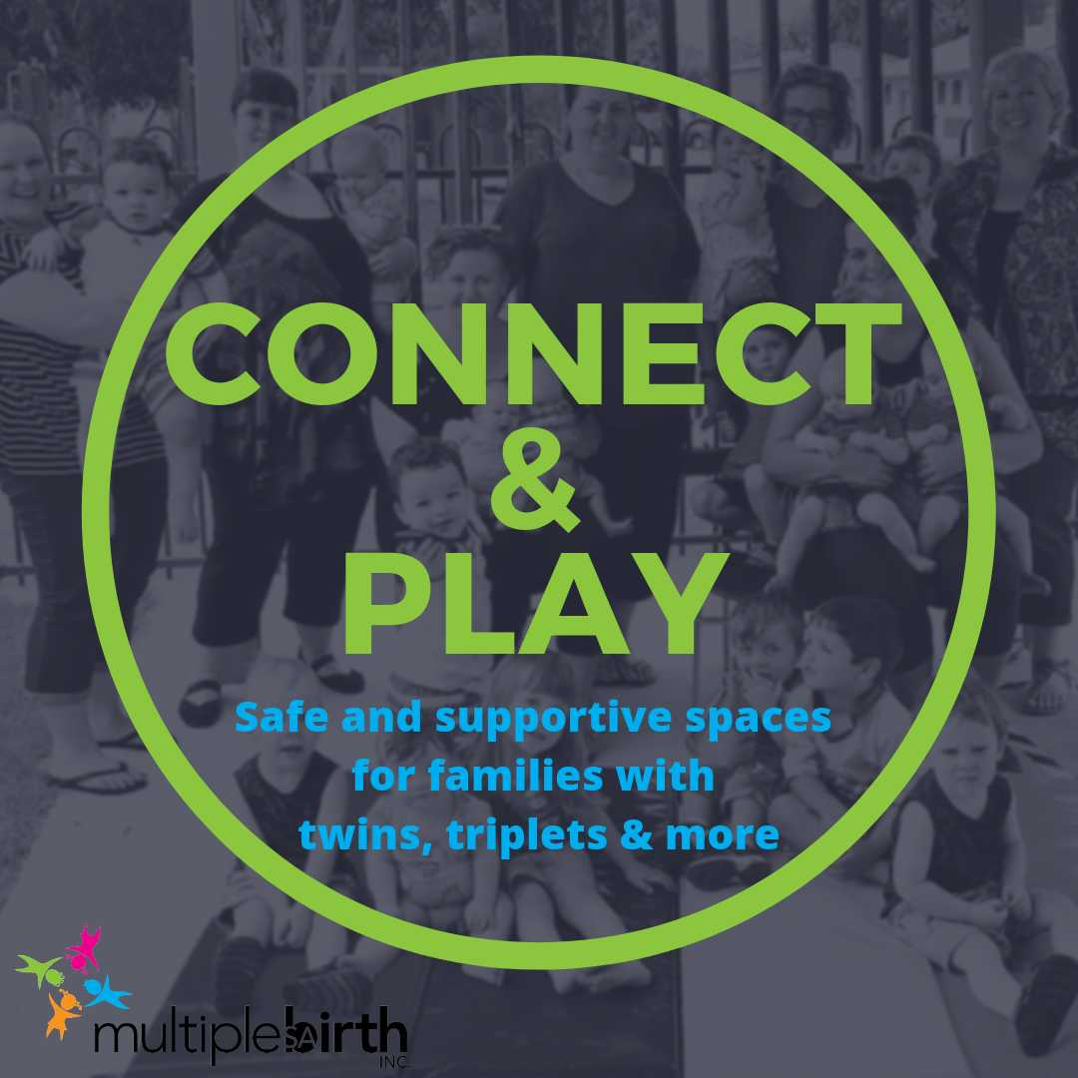
Places in programs must be booked prior to arrival - For all Enquires and Booking please contact: 8333 2557

