Monday | Tuesday | Wednesday | Thursday | Friday
Preschool  8.30am- 4.00pm | Preschool  8.30am- 4.00pm | Preschool  8.30am- 4.00pm | Preschool  8.30am- 4.00pm | Trinity Gardens Preschool: 8333 2557
 | CAFHS  Contact 1300 733 6056 to make a booking | CAFHS  Contact 1300 733 6056 to make a booking | CAFHS  Contact 1300 733 6056 to make a booking | CAFHS  Contact 1300 733 6056 to make a booking
Occasional Care  A now and then childcare service for children prior to preschool age  8.30am – 11.15am  Contact: 8333 2557 | Child Wellbeing Service  Annemarie Monck  Fortnightly  in the School term  8.30am- 4.30pm  For further information contact: 0488 016 586 or  amonck@actnowpsychology.com | Wednesday Playgroup  Community playgroup for families with toddlers and children under 5  Starting 14th October  9.00am – 11.00am  Contact: 8333 2557 | Occasional Care  A now and then childcare service for children prior to preschool age  8.30am – 11.15am  Contact: 8333 2557 | Pre-schoolers Playgroup  Playgroup for families with children 3 to 5 years  Siblings welcome  Starting 16th October  9.00am – 11.00am  Contact: 8333 2557
Links to Wellbeing  Peri Natal Wellbeing  Counselling for Mothers and Fathers who have child 1 year and younger  Fortnightly  9.00am- 4.30pm  For further information contact:  Ph: 8326 3591 | Steiner Playgroup  Steiner inspired playgroup for families with toddlers and children under 5  9.00am – 11.00am  Starting 20th October  Contact: adelaidesteinerkindy@yahoo.com | My Time  Support group for parents and carers who are caring for a child with a disability, medical condition or developmental delay  Starting 14th October  Enquires and bookings  Silvana: 0488 151 789 | Occasional Care  A now and then childcare service for children prior to preschool age  12.30pm – 3.15pm  Contact: 8333 2557 | 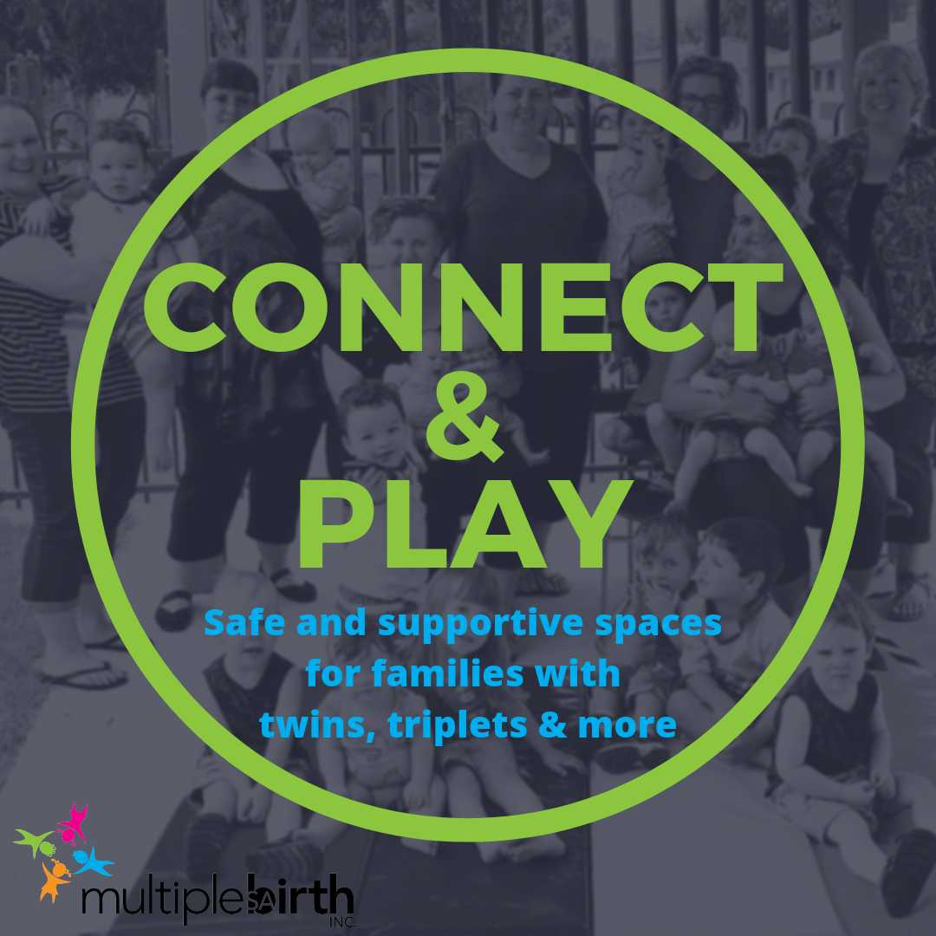
 | Multiple Births Assoc  Two Plus & Us  a safe and supportive space for families with twins, triplets & more to connect and play  11.30am – 1.00pm  Contact: Erin O’Halloran  erin.a.ohalloran@gmail.com | Financial Counselling Service  By Referral  Contact: 1800 615 677 or  vickie.lindeblad@unitingcommunities.org | Midwife Clinic  8.30am- 4.30pm  Contact the pregnancy SA Referral line on  1300 368 820  www.childrenscentres.sa.gov.au/antenatal | Dad’s Playgroup  An opportunity for Dads (any male caregiver) and children to interact and socialise with other Dads in play based setting.  Birth to 6 years  Saturday  10th October  31st October  28th November  10am to 11.30am  Call on 8333 2557 to register your interest in this group
Be You is a national initiative for educators, aimed at promoting and protecting positive mental health in children and young people. | Early Parenting Group  (5 week program)  2.00pm- 4.00pm  Facilitated by Child and Family Health Service staff (CaFHS)  1300 733 606 | Fun with Family Music  Bringing parents, children and babies together with music  Facilitated by Penny Hewson  3.30pm- 4.30pm  Starting 14th October  Contact: 8333 2557
Safer Family Services at the Trinity Gardens Children’s Centre can provide information and support  to families including parenting and child development.  Community Development Co-ordinator  Cathy Tomaselli  Ph: 8333 2557 |  | CaFHS  1300 733 606  for Bookings | www.facebook.com/trinitygardens.childrenscentre  and more information about our services and  what we offer on www.trinitygardenscc.sa.edu.au/
What’s On - Term 4 2020
12th October to 11th December

p
Places in programs must be booked prior to arrival - For all Enquires and Booking please contact: 8333 2557
Group times and dates are subject to change at any time.

160 Portrush Road, Trinity Gardens (Enter via Devitt Ave)

