

**West Torrens Partnership**

**PRE SCHOOL WAITING LIST**

To ensure all families have equitable access to their local preschool, this pre enrolment form has been developed by the Cowandilla Children’s Centre, Jean Horan Kindergarten, Kurralta Park Community Kindergarten, Lockleys Children’s Centre, Netley Kindergarten and the Torrensville Preschool Centre.

Please complete the details overleaf if you are considering attending any of the above centres.

By nominating your preschools in order of choice, within the criteria, your child will be added to a waiting list for enrolment in a preschool program.

All Preschool Directors will work together in Term 3 each year to allocate positions. Families will be notified by mail of their allocated preschool when their child is eligible as outlined in the DECD Preschool Enrolment Policy.

The number of vacancies available at each centre depends on the preschool’s physical capacity. Please read the priority of access below to understand the likelihood of your child being placed in a Priority 1 or 2 list.

**PRIORITY OF ACCESS**

All West Torrens Partnership Preschools operate a Priority of Access procedure to manage enrolments where the demand for preschool places exceeds the centre capacity. This aims to support all local preschools and equitable access by families to a preschool service, when limited vacancies exist.

**Priority is given to enrolments that meet any of the following criteria:**

Priority 1

1. Children who live within the kindergarten’s Priority of Access areas.
2. The circumstances of the child and the family, such as a child’s special rights, cultural, linguistically diverse backgrounds (at the discretion of the Director)

Priority 2

1. Siblings currently attend Cowandilla Primary School **OR**
2. Children whose siblings have previously attended the preschool previously **OR**
3. Children who already attend an associated program at the preschool – e.g. playgroup, occasional care

Families wishing to enrol their children at another preschool, even though there is a preschool closer to their residential address, will only be offered positions if, and when, there are vacancies after all other children have been allocated a place.

|  |  |  |
| --- | --- | --- |
| **Preschool Preferences - Please number preschools in order of choice 1-3** | | |
|  | Cowandilla Children’s Centre | 21 Jenkins St., Cowandilla SA 5033 |
|  | Jean Horan Kindergarten | Ross Ave. Flinders Park SA 5025 |
|  | Kurralta Park Community Kindergarten | 35 Barwell Avenue Marleston SA 5033 |
|  | Lockleys Children’s Centre | 57 Malurus Ave., Lockleys 5032 |
|  | Netley Kindergarten | Comet Avenue Netley SA 5037 |
|  | Torrensville Preschool | 93a Ashley Street Torrensville 5031 |
|  | Other … please detail |  |

**Cowandilla Preschool Priority Catchment Area Map**

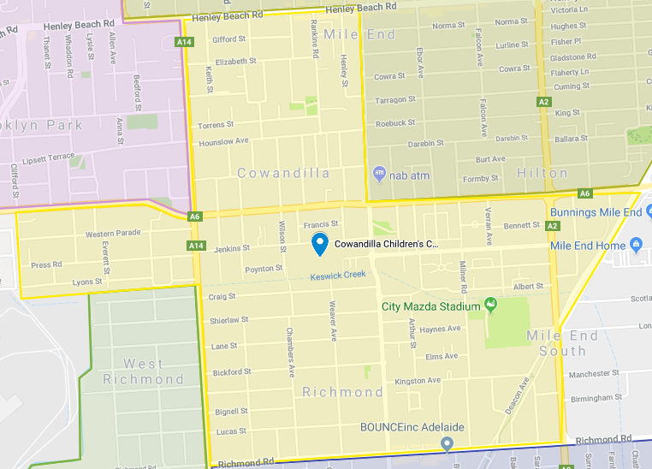

|  |
| --- |
| **PRESCHOOL WAITING LIST** |
| Please complete the details overleaf to place your child’s name on the waiting list for enrolment in the preschool program when she/he is eligible, as outlined in the DECD Preschool Enrolment Policy.  You will be notified if a place is available prior to your child’s anticipated commencement date; you will then be asked to complete a Preschool Enrolment Form.  The number of vacancies available at each intake depends on the preschool’s physical capacity and the number of children leaving to go to school and therefore will vary at each intake.  **INFORMATION PRIVACY STATEMENT**  The Department for Education and Child Development (DECD) is committed to respecting the confidentiality of information provided by children/students and parents, for example, information requested on child/student enrolment forms.  The information requested in this form is to enable the site and DECD Regional Office to manage projected enrolments.  The information provided on the waiting list form is stored securely in local school/preschool and DECD databases. The disclosure of personal information held by Government is regulated by the information privacy principles (see reference above). Unless required to do so by a law of the State or Australian Government, as permitted by the information privacy principles or in accordance with the information sharing guidelines (see below), DECD will not otherwise disclose the information to others without your consent.  **INFORMATION SHARING STATEMENT**  There will be occasions where sharing information with others outside this site will be important to your child’s child care placement. In these circumstances, DECD follows the SA Government’s *Information Sharing: Guidelines for promoting the safety and wellbeing of children, young people and families (ISG).* [www.gcyp.sa.gov.au](http://www.gcyp.sa.gov.au)  Under the ISG your consent for the sharing of personal information about your child will be sought and respected in all situations unless:   * it is unsafe / impossible to gain consent or consent has been refused and * without information being shared, a child or children will be at increased risk of serious harm.   **PRIORITY OF ACCESS**  **Please see West Torrens Partnership information attached  and complete the table below:**   |  |  |  | | --- | --- | --- | | **Child’s Name:** | | | | My child resides in the Priority of Access area of the Preschool (see map ) | **Yes** | **No** | | Siblings attend Cowandilla Primary School | **Yes** | **No** | | Siblings of children in the family have previously attended Cowandilla Preschool | **Yes** | **No** | | Child regularly attends an associated program-Play group/Occasional care at Cowandilla Children’s Centre | **Yes** | **No** | | School that you will be enrolling your child ………………….…………………………………………………………. | | | | Special Circumstances that you would like to be considered: | | | |



Cowandilla Preschool

**Form**

**W**P

|  |  |  |  |  |  |  |  |  |  |  |  |  |  |  |  |  |  |
| --- | --- | --- | --- | --- | --- | --- | --- | --- | --- | --- | --- | --- | --- | --- | --- | --- | --- |
| Site details | | | | | | | | | | | | | | | | | |
|  | | |  | | | | | | | | | | | | | |
| **Site name:** | | | **Cowandilla Preschool** | | | | | | | | | | | |  | |
|  | | |  | | | | | | | | | | | | | |
| **Child details** | | | | | | | | | | | | | | | | |
|  | | |  | | | | | | **Does your child have any additional needs or a diagnosed disability?**  No  Yes  **If yes, please provide details:** | | | | | | | |
| **First name:** | | |  | | | |  | |
|  | | |  | | | | | |
| **Surname/ Family name:** | | |  | | | |  | |
|  | | |  | | | | | |
| **Date of birth:** | | |  | | | |  | |  | |  | | | |  | |
|  | | |  | | | | | |
| **\* Proof of age must be provided prior to enrolment** | | | | | | | | |
| **Gender:** Male  Female | | | | | | | | |
| **Address:** | |  | | | | |  | |
|  | |  | | | | | | |
| **Suburb/Town:** | |  | | | | |  | |
|  | |  | | | | | | | **Does your child have a medical condition that may require support?**  No  Yes  **If yes, please provide details:** | | | | | | |  |
| **Postcode:** | |  | | | | |  | |
|  | |  | | | | | | |
| **In which country was your child born?** Australia Other  **Please specify**    **If your child speaks a language other than English at home, what**  **languages (including English) does your child speak?**    **Is your child of Aboriginal or Torres Strait Islander origin?**  No  Yes, Aboriginal  Yes, Torres Strait Islander | | | | | | | | |
|  | |  | | | |  | |
| **Is this child under the Guardianship of the Minister for Families and Communities or in alternative care?**  No  Yes  *If Yes, further details must be obtained from the confidential Families SA-DECD*  *Information Sharing Form at the time of enrolment, supplied to the preschool site leader by the child’s Families SA caseworker.* | | | | | | | | |  | |  | |
|  | |  | |
| **Parent / Guardian details** | | | | | | | | | | | | | | | | |
|  | | |  | | | | |  | |  | | |  | |  | |
| **Given name:** | | |  | | | | |  | | **Home phone:** | | |  | |  | |
|  | | |  | | | | |  | |  | | |  | |  | |
| **Family name:** | | |  | | | | |  | | **Mobile:** | | |  | |  | |
|  | | |  | | | | |  | |  | | |  | |  | |
| **Relationship to child:** | | |  | | | | |  | | **Email:** | | |  | |  | |
|  | | |  | | | | |  | |  | | |  | |  | |
| **Signature:** | | |  | | | | |  | | **Date:** | | |  | |  | |
|  | | |  | | | | |  | |  | | |  | |  | |
| **Details of person completing waiting list form** (if other than parent/ guardian ) | | | | | | | | | | | | | | | | |
|  | | | | | | | | | |  | | | | |  | |
| **Name:** | | |  | | | | |  | | **Role:** | |  | | |  | |
|  | | |  | | | | |  | |  | |  | | |  | |
| **Signature:** | | |  | | | | |  | | **Date:** | |  | | |  | |
|  | | | | | | | |  | |  | |  | | |  | |
| **Site use only** | | | | | | | |  | | | | | | |  | |
| **Priority of Access assigned**  **Preschool preferences**        **Closest Preschool** | | | | | | **Anticipated Preschool start dates**  **Early entry** (if eligible and capacity permits)  start: term  year  Date:  **Pre entry** start: term  year  Date:  **Preschool** start : term  year  Date:  **School** start: term  year  Date: | | | | | | | | Date enrolment details entered in EYS:    EDID**:**    Date contacted:  If place available, enrolment interview scheduled on  Time  Enrolment form completed on:  Group/Room: | | |
| **Term dates** | | | | | |
|  | **2018** | | | **2019** | **2020** |
| **T 1** | 29/1-13/4 | | | 29/1-12/4 | 28/1-9/4 |
| **T 2** | 30/4-6/7 | | | 29/4-5/7 | 27/4-3/7 |
| **T 3** | 23/7-28/9 | | | 22/7-27/9 | 20/7-25/9 |
| **T 4** | 15/10-14/12 | | | 14/10-13/12 | 12/10-11/12 |